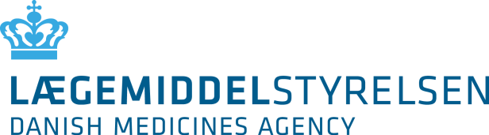

Application for generel reimbursement or general conditional reimbursement for a medicinal product

based on a negotiated confidential price

Pilot arrangement for the period 1st of July 2025 – 30th of June 2028
Product name: | Pharmaceutical form:
Active substance(s): | Dosage (DDD, if established):
Approved indication(s):

Patient group for which the confidential price has been negotiated:

Suggested reimbursement clause, if the patient group differs from the one for which the confidential price has been negotiated:

ATC group or therapeutic classification: |  |  | Dispensing status:
Strength(s): | Package size(s): |  | Negotiated confidential PPP (DKK) |  | Negotiated confidential maximum PPP (DKK)
Time period for the agreement with Amgros on a confidential price,  if applicable: |  |  |  | Do you want to present the application for the Reimbursement Committee?¹  Yes ☐ No ☐
Date of marketing authorisation: |  | Expected marketing date of the medicinal product in Denmark: |  | Has a health economic evaluation been attached?  Yes ☐ No ☐
Company name and address: |  |  |  |  | Date and signature:
Contact person: |  |  |  |  | Date and signature:
Telephone number: | E-mail address: |  |  |  | Date and signature:
¹ It is the Danish Medicines Agency’s decision whether the application should be presented to the Reimbursement Committee.

