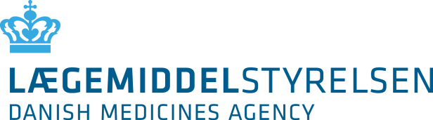

Application Form for Consultation by a Notified Body on an Ancillary Medicinal Substance in a Medical Device
Send this form with accompanying documentation to: med-udstyr@dkma.dk

- Date of request
Click here to write date

- Application details
2.1 Name/type of medical device
Click here to write text

2.2 Ancillary medicinal substance(s)
Click here to write text

2.3 Strength/amount in medical device
- If different variants, please add them here:
Click here to write text

- Notified Body
3.1 Name
Click here to write text

3.2 Person authorized to communicate on behalf of notified body
Click here to write text

3.3 Street address
Click here to write text

3.4 Postal code and city
Click here to write text

3.5 Country
Click here to write text

3.6 E-mail
Click here to write text

3.7 Telephone number
Click here to write text

3.8 Billing address (if different from above)
Click here to write text

3.9 CVR number for billing address (if Danish)
Click here to write text

3.10 Purchase order number (if relevant)
Click here to write text

- Applicant for device approval (for CE-marking)
4.1 Name
Click here to write text

4.2 Contact person
Click here to write text

4.3 Address
Click here to write text

4.4 Country
Click here to write text

- Manufacturer of the ancillary medicinal substance
5.1 Name
Click here to write text

5.2 Contact person
Click here to write text

5.3 Address
Click here to write text

5.4 Country
Click here to write text

5.5 E-mail
Click here to write text

5.6 Telephone number
Click here to write text

5.7 EU-GMP verification should always be provided for the medicinal substance manufacturer

☐ EU-GMP verification

5.8 If an Active Substance Master File is submitted a letter of access should be provided

☐ Letter of access Applicant´s and Restricted part of the Active Substance Master File (ASMF)

☐ Not applicable

5.9 If more than one manufacturer is applied for, add the additional manufacturer details here:
Click here to write text

- Classification of application
☐ New active substance (NAS) in Denmark

☐ Known active substance within a new therapeutic area

☐ Known active substance within an established therapeutic area

☐ Tissues or cells of human origin (non-viable)

☐ Device itself composed of substance absorbed by or locally dispersed in the body

☐ MDR-reassessment

☐ Transfer from current competent authority to the DKMA

- For initial consultations
7.1 Ref no assigned by the DKMA for the request of scientific consultation
Click here to write text

7.2 Date of presubmission meeting (if applicable)
Click here to write text

- For MDR-reassessments and/or Transfer from current NCA to the DKMA
For a product that has previously been consulted on under MDD a new scientific consultation (an MDR-reassessment) is needed prior to the first certification under the MDR-legislation.

☐ Full documentation package is submitted

☐ Copies of all Assessment reports by previously consulted NCA is submitted

☐ List of changes since the initial consultation is submitted

☐ No changes since the initial consultation (certificate submitted)

☐ DKMA was the initially consulted NCA

8.1 Transfer from NCA (to be specified):
Click here to write text

8.2 Planned transfer date:
Click here to write text

8.3 – DKMA Ref no for previous scientific consultation
Click here to write text

- Signature
9.1 Signature
Click here to write text

9.2 Name of company
Click here to write text

9.3 Name in printed letters
Click here to write text

9.4 Date (YYYY-MM-DD)
Click here to write text

