XX June 2021
URGENT
MEDICAL DEVICE RECALL
GLIDESCOPE® GO™ MONITORS
«PrimaryContactName»
«CustomerName»
«Address1»
«City», «State» «ZipCode»

Dear «CustomerName»,
The purpose of this letter is to advise you that Verathon Incorporated is conducting a voluntary recall for select GlideScope® Go™ monitors (GlideScope Go). This voluntary recall notification relates to GlideScope Go’s IP67 rating. Verathon has received five (5) complaints regarding fluid ingress for GlideScope Go since 31 August 2017.
Our records indicate that your facility has received one or more devices affected by this notice. We require customers to respond to this recall by completing the attached Recall Response Form and returning it to Verathon by email to CSNotifications@verathon.com.

Please follow the instructions under ‘Actions to be Taken by the Customer/Distributor’ beginning on page 3 of this letter and return the Recall Response Form on page 5.
Thank you for your immediate attention to this matter. Verathon is committed to providing products of the highest quality, and we regret any inconvenience these actions may cause. We encourage you to contact us if you need assistance or further information.
As with any concerns with Verathon products, please report suspected malfunctions or adverse events related to GlideScope devices to Verathon Customer Care on +44 (0) 1494 719 420 or email us at CSNotifications@verathon.com.
Yours sincerely,

Corey Kasbohm
Complaint Handling Unit Supervisor

URGENT
MEDICAL DEVICE RECALL

Affected products: GlideScope® Go monitors
(Distributed between 31 August 2017 and 23 March 2021)

[In
GlideScope Go is a handheld video monitor intended for use by qualified medical professionals to obtain a clear, unobstructed view of the airway and vocal cords for medical purposes. GlideScope Go monitors distributed between 31 August 2017 and 23 March 2021 are within scope of this recall.
Reason for the voluntary recall:

GlideScope Go is labelled with a IP67 rating, which means it can be submerged to one metre (3.28 feet) for 30 minutes without fluid ingress resulting in loss of function. Verathon Incorporated has become aware of a variation in material thickness of a micro USB mounting plate supplied to Verathon. This thickness variation can impact the vertical centring of the micro USB receptacle within the housing and could lead to insufficient sealing, and the device may fail to meet the IP67 rating.

Verathon is aware of five (5) customer complaints, since launch, related to fluid ingress. There have been no (0) instances of patient injury or death reported as a result of fluid ingress.

Figures 1 and 2: Representative images of fluid ingress seen in GlideScope Go monitors

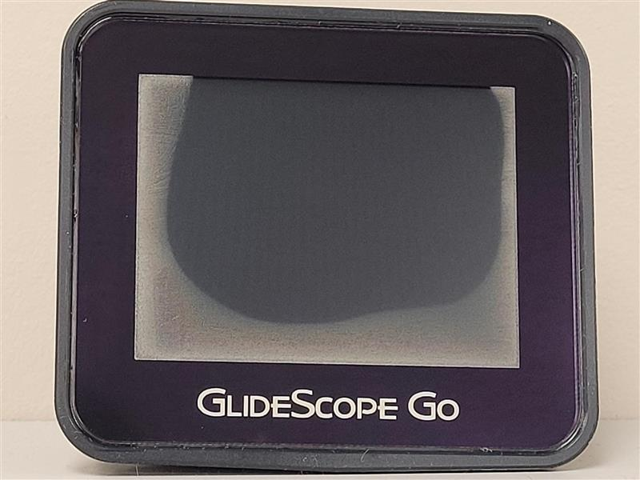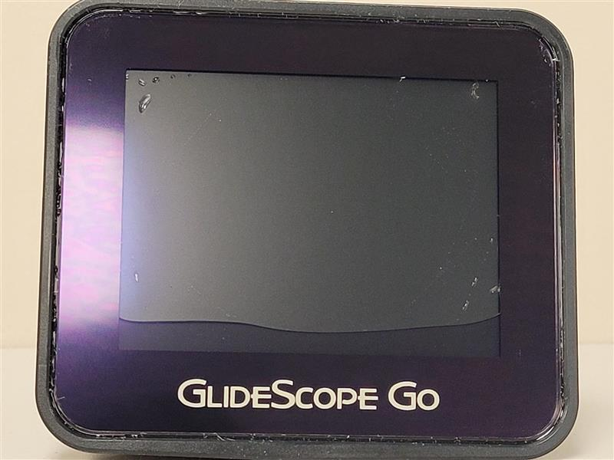

This Field Safety Notification is being conducted to inform customers who purchased devices between
31 August 2017 and 23 March 2021 that the GlideScope Go monitor may be susceptible to fluid ingress.

Risk to health:

Verathon is not aware of any instances of patient or user injury attributed to this issue. If using submersion
to clean/disinfect the GlideScope Go Monitor, the insufficient sealing around the micro USB connector could result in damage to the monitor and may impair functionality. If there is fluid ingress, the image display may be disrupted or the monitor rendered inoperable (will not power on). This may necessitate the use of
back-up equipment.

Actions to be taken by the customer/distributor:

Our records indicate that your facility has received one or more GlideScope Go monitors that are impacted by this recall.

Please take the following actions:
- Perform a visual inspection of the GlideScope Go Monitor for fluid ingress; please refer to figures 1 and 2 above for visual examples of failure to meet the IP67 rating.

- Based on the visual inspection of your device(s), please do one of the following:

- If your GlideScope Go monitor has no fluid ingress or you do not wish to return your GlideScope Go, complete the attached Recall Response Form by indicating ‘no’ or ‘0’ in the text box and return the form to Verathon by email to CSNotifications@verathon.com.

Or

- If your GlideScope Go monitor has fluid ingress and you would like these units serviced (similar to Figures 1 and 2 above) complete the attached Recall Response Form. You will need to indicate, by number, the count of GlideScope Go monitors that require service in the text box and return the form by email to CSNotifications@verathon.com. Verathon Customer Care will contact you to arrange replacement of your GlideScope Go Monitor.

- If you have completed and returned your Recall Response Form stating ‘no’ or '0’ in the text box, indicating no evidence of fluid ingress, please continue to routinely inspect your GlideScope Go Monitor in accordance with the instructions in your Operation and Maintenance Manual. Should your GlideScope Go Monitor experience fluid ingress as depicted in Figures 1 and 2 in this letter, please contact Verathon Customer Care at CSNotifications@verathon.com to arrange for your device to be returned and inspected. Verathon will replace your GlideScope Go monitor if there is evidence of fluid ingress caused by insufficient sealing around the micro USB connector.

Customer Care Agents are available to speak with you Monday to Friday from 08:30 to 17:00 Central European Time (CET) at +44 (0) 1494 719 420. You may also email us at CSNotifications@verathon.com, and we will respond promptly.
Should you experience adverse reactions or quality problems relating to the use of this product, or any other Verathon product, they may be reported to the FDA’s MedWatch Adverse Event Reporting program either online, by regular mail or by fax.

Action to be taken by Verathon:
As a corrective action, Verathon is implementing a change in the design for the GlideScope Go monitor micro USB mounting plate. This change will reduce the variation in the mounting plate thickness and meet the IP67 rating.
Verathon is voluntarily undertaking this recall to replace GlideScope Go monitors that are impacted by
fluid ingress.
Should you have any questions about this Field Safety Notice, please contact your Verathon representative or Verathon Customer Care at CSNotifications@verathon.com
Our records indicate that your facility has received one or more GlideScope® Go™ monitors.
Please fill in and return this Recall Response Form.
RECALL RESPONSE FORM: RESPONSE REQUIRED
Affected products: GlideScope® Go™ monitors
(Distributed between 31 August 2017 and 23 March 2021)

(Please indicate a number in the box below)

My facility has inspected our GlideScope Go Monitors, see Appendix 1 for a list of Serial Numbers, and request that ________ units be serviced. Please list the Serial Numbers that require service below, if additional space is required please include as an attachment.

If no fluid ingress is observed and/or you do not wish units to be serviced, indicate ‘no’ or ‘0’ in the
box above.

If a number other than 0 is listed, Verathon will contact you to schedule service.

GlideScope Go monitor serial numbers

Please sign, date and print your name and title below. Thank you!

Customer information
Business name: «CustomerName»
Address: «Address1»
City, County Postcode: «City», «State» «ZipCode»
Signature: | Phone:
Printed name: | Date:

Please email the completed form to:
CSNotifications@verathon.com

Appendix 1: List of Serial Numbers:

«CustomerName»

