Field Safety Notice

Trilogy Evo and Trilogy Evo O2 (“Device(s)”)

FOLLOW UP COMMUNICATION

20-January-2022

This letter contains important information for the continued safe and proper use of your equipment

Please review the following information with all members of your staff who need to be aware of the contents of this communication. It is important to understand the implications of this communication.

Please retain a copy with the equipment Instruction for Use.

Dear Customer,

This is a follow-up communication to the Philips Field Safety Notice letter for the Trilogy Evo and Trilogy Evo O2 2017-07-A sent in July and October 2021. This notice is intended to inform you about the following:

- Additional steps may be required in the process of applying the software correction. These steps are added to the Trilogy Evo Software Upgrade procedure in section 4C of this letter.

- What the problem is, under what circumstances it can occur, and when should it be corrected

Two software issues have been identified related to pressure changes. The first issue is described as Infant/Pediatric EFS Calibration Pressure Increase and the second issue is described as Pressure Drift (Continuous Usage).

Issue 1 – Infant/Pediatric EFS Calibration Pressure Increase

An increase in the expiratory pressure (EPAP/PEEP) can occur when the pediatric/infant External Flow Sensor (EFS) is used with an Active Flow or Dual Limb circuit and a manual circuit calibration is performed. This increase in pressure will be seen shortly after starting therapy within approximately 1 to 2 minutes. The maximum expiratory pressure increase may reach up to 10 cmH₂O above the set pressure. The inspiratory pressure (Pressure Support/Pressure Control/IPAP) may also be affected. Devices’ software MUST be upgraded as soon as possible.

Issue 2 – Pressure Drift (Continuous Usage)

When a Trilogy Evo or Trilogy Evo O2 model is used continuously without any interruption of therapy over weeks to months, the baseline pressure (that is, the pressure initially set for the patient) may increase or decrease at a rate of up to approximately 2 cmH2O per month. This change applies to the PEEP and the inspiratory pressure at the same rate. The maximum pressure deviation that could be seen is a 10 cmH2O shift from the baseline pressure. The pressure regulation alarms will not annunciate with this issue.

This issue applies to the following modes: CPAP, PSV, S/T, A/C-PC, SIMV-PC, SIMV-VC (PEEP and Pressure Support), and A/C-VC (PEEP).

The User Interface (display screen) or Care Orchestrator/Care Orchestrator Essence will display the actual pressure that the patient is receiving, which will differ from the baseline setting when this condition occurs.

For Issue 2, Pressure Drift (Continuous Usage), before upgrading a Device with the new software version (1.05.02.00), a Respiratory clinician or Physician should use one of the following methods to check the Device to determine if a pressure drift has occurred, as the pressure alarms will not detect it.

- The Respiratory clinician or Physician can detect the increase/decrease in pressure by observing the pressure Trend report in Care Orchestrator/Care Orchestrator Essence as shown below.

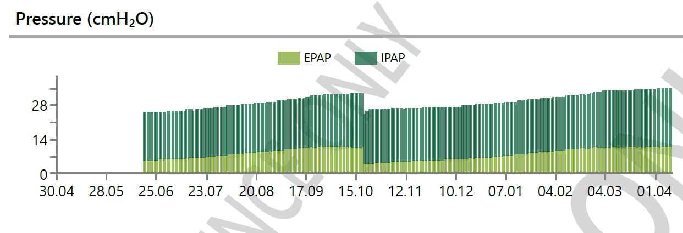

- The Respiratory clinician or Physician can detect the increase in pressure by observing the measured parameters on the Device’s screen (measured PIP value or pressure waveform as shown below where the IPAP is set to 15 cmH2O but because of the pressure increase the actual delivered pressure is 16.9 cmH2O).

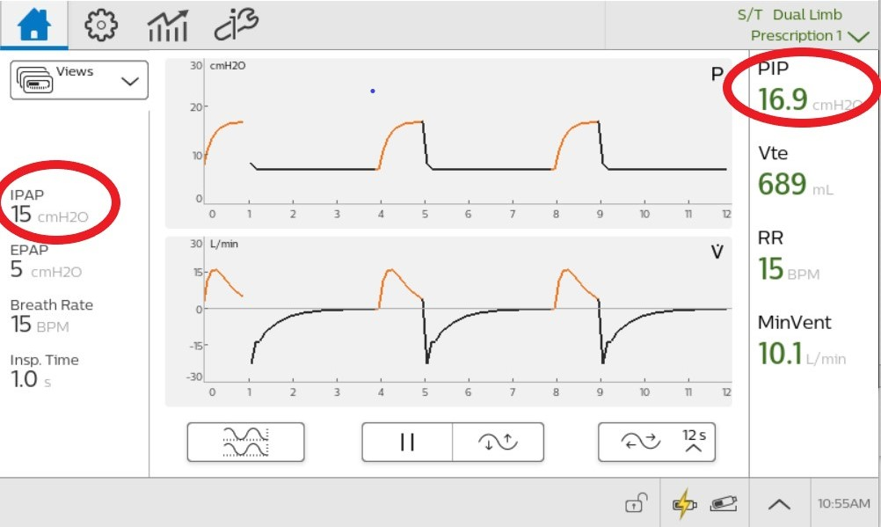

If a pressure drift is detected, the decision of when to upgrade the Device software MUST be made in consultation with a clinician. During the upgrade, take steps to support the patient during a brief interruption in therapy, as needed.
If a pressure drift is NOT detected, the Device software MUST be upgraded as soon as possible.
- Describe the actions planned by Philips to correct the problem

Philips has released a software correction for these issues. There will be three (3) options to obtain the software version (1.05.02.00) to complete the upgrade:
- The software is available via the “My Philips for Professionals” (“MyP4P”) website for customers to upgrade Devices. If you would like to obtain the software this way, then follow the instructions in section 3, below;
- Philips will provide separately via email a Secure Download Link to download a file called “Trilogy Evo.upg”. You must copy the file onto a USB flash drive and follow the instructions in section 3C, below. You should contact your local Philips sales representative if you want to receive this Secure Download Link via email; and
- Philips will make a USB flash drive with the software included available for order – this was released mid-October, 2021 (again, follow the instructions in section 3C, below).

- Trilogy Evo Software Upgrade procedure
- Download of Software from MyP4P website
This section will outline the steps to download the latest Trilogy Evo software on a USB flash drive.
MyP4P is not compatible with Internet Explorer. Access MyP4P using Microsoft Edge, Chrome, or Firefox browsers.

- Log onto https://www.my.philips.com/ with your customer account and password.

- Click on the Documents tab

- Use the search tool and type: Trilogy Evo

- Click on “Product Software” under the “Document Type” filter on the bottom left side of the screen (below Filters)

- Click on “Trilogy Evo” under the “Product” filter

Please download the version 1.05.02.00.

- Downloading Trilogy Evo SW to a USB flash drive

- Connect a USB flash drive to the PC. (Minimum memory size should be 2 GB or greater).

- Click on the file and this will be automatically downloaded. This file is in a compressed format (.zip).

- Save the Trilogy Evo Upgrade zip file to a known location.

- Unzip the file and an .exe file will be available.

- Run the .exe file to self-extract the software update file.

- During the self-extraction, select the USB flash drive location to unzip the file to the flash drive location.

- Winzip will copy the TrilogyEvo.upg file to the USB flash drive. Acknowledge the prompts and close WinZip.

- The USB flash drive will then contain the software update file necessary to upgrade the Device software.

- Upgrading Trilogy Evo software.

- Turn the device to Off state (black screen)

- Disconnect AC power

- Wait 6 minutes to let the device go to Sleep

- Plug-in AC and once the device boots up, insert the USB-flash drive in any of the two USB ports of Trilogy Evo.

- Go to the OPTIONS window (wrench icon) > Data Transfer

- Trilogy Evo will recognize the USB flash drive and will show the Software version on the “Install Software Update” box. Click on that box.

- Confirm whether you are upgrading the Device to the latest version (which should be 1.05.02.00). If correct, then click “YES.”

- Trilogy Evo should now be installing the new software. Please, wait.

- Once the new software is installed, a confirmation that the Software installation is complete will be shown. Press OK and turn the ventilator ON.

If you need any further information or support concerning this issue, please contact <Philips representative contact details to be completed by the Market>

Please complete the included Field Safety Notice Response Form and return by email per the instructions in the Form as soon as possible but not later than May 31, 2022.

Philips regrets any inconvenience caused by this problem.

Sincerely,

Rodney Mell
Head of Quality
Philips Sleep and Respiratory Care

Please complete and return all pages of this Form as soon as possible but not later than May 31, 2022:

- Email - enter local email

- Fax – enter local fax number

Trilogy Evo and Trilogy Evo O2 Devices

Material Number | Serial Number | Status (Select One)
 |  | Device Upgraded with Software Version 1.05.02.00 | Device Not Found | Device Destroyed

