URGENT FIELD SAFETY NOTICE - EXTENDED

Commercial Name of the Product:

ICC Code | SAP Code | Product Description | Lot Number | Date of Mfg | Market Unit Qty
403711 | 1186118 | AQUACELTM Ag Dressing 20x30cm (1x5pk) | 0A03126 | 20 Jan 2020 | 959 packs = 4795 dressings
403711 | 1186113 | AQUACELTM Ag Dressing 20x30cm (1x5pk) | 9L04131 | 02 Dec 2019 | 1440 packs = 7200  dressings
413569 | 1708965 | AQUACELTM AG+ EXTRA 20X30CM(1X5PK) | 0A01855 | 15th Jan 2020 | 1800 packs = 9000  dressings

Issue Date: May 2021
Original Notice X Revised Notice Revision No.: Rev. 2

FSCA Ref: 2020-003.1

Type of action: Field Action/Product Disposal

Please note that this action only applies to product codes 403711 and 413569 and LOTs 0A03126, 9L04131 and 0A01855 of AQUACELTM Ag Dressing 20x30cm (1x5pk) and AQUACELTM AG+ EXTRA 20X30CM(1X5PK).

Date: -- May 2021

Details on affected devices:
AQUACELTM Ag Dressing is a soft, sterile, non-woven pad or ribbon dressing composed of Hydrofiber™ and ionic silver. It is used to dress exuding wounds that are infected or are at risk of infection. It is manufactured in both flat dressing and ribbon formats and is available in a range of dressing sizes. The silver in the dressing kills a broad spectrum of wound bacteria, and aids in creating an antimicrobial environment. The dressing absorbs high amounts of wound fluid and bacteria and creates a soft, cohesive gel that intimately conforms to the wound surface, maintains a moist environment and aids in the removal of non-viable tissue from the wound (autolytic debridement). A moist wound environment and control of wound bacteria support the body’s healing process and helps reduce the risk of wound infection. The base material of the product is Sodium Carboxymethylcellulose (NaCMC) known as Hydrofiber™. The Hydrofiber™ is the same as AQUACELTM dressing and typically accounts for 98.8% w/w of the AQUACELTM Ag base dressing. The dressing also contains 1.2% w/w of silver in ionic form. This concentration has been shown to be effective against wound pathogens in in-vitro testing. AQUACELTM Ag dressings are intended as non-invasive devices which may be used for the treatment of wounds that breach the dermal layers of the skin and therefore require healing by secondary intent. The integral ionic silver content acts as a medicinal product ancillary to the dressing. Therefore, in accordance with Rule 13 of Annex IX of the Medical Device Directive 93/42/EEC, the devices referred to in this Risk Management Report are classified as class III devices in the EU/EEA.

AQUACELTM Ag+ EXTRA is an anti-microbial dressing that combines the physical design characteristics of AQUACELTM in the form of a dual layer of sterile, soft, pliable, grey coloured, nonwoven fibrous HydrofiberTM, with the anti-microbial technology used in AQUACELTM Ag+. The base material of this product range is Sodium Carboxymethylcellulose (NaCMC), (HydrofiberTM) and typically accounts for 98.8% w/w of the AQUACELTM Ag base dressing. The dressing is composed of dual carded silvered (1.2% w/w) HydrofiberTM Ag+ webs with low levels of Ethylenediaminetetra-acetic acid di-sodium salt (EDTA) (0.39%w/w) and benzethonium chloride (BeCl) (0.135%w/w) (as per AQUACELTM Ag+ dressing), that are reinforced with TencelTM yarn stitch bonded in both warp and weft stitch patterns. The dressing absorbs high amounts of wound fluid and bacteria and creates a soft, cohesive gel that intimately conforms to the wound surface to help eliminate dead spaces, maintains a moist environment and aids in the removal of non-viable tissue from the wound.

Figure 1: AQUACELTM Ag Dressing 20 x 30 Carton Secondary Packaging

Figure 2: AQUACELTM Ag Dressing 20 Figure 3: AQUACELTM Ag Dressing
x 30cm Dressing 20 x 30cm Foil Primary Packaging

Figure 4: AQUACELTM AG+ EXTRA 20 x 30cm Carton Secondary Packaging

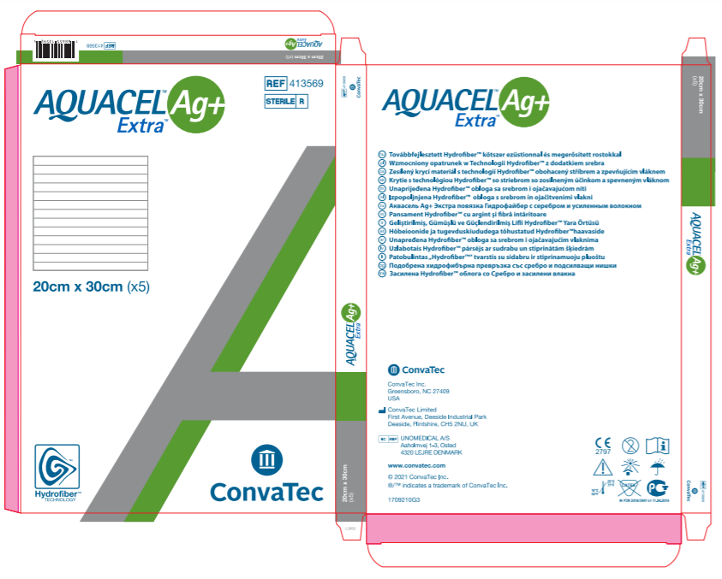

Figure 5: AQUACELTM AG+ EXTRA 20 x Figure 6: AQUACELTM AG+ EXTRA
x 30cm Dressing 20 x 30cm Foil Primary Packaging
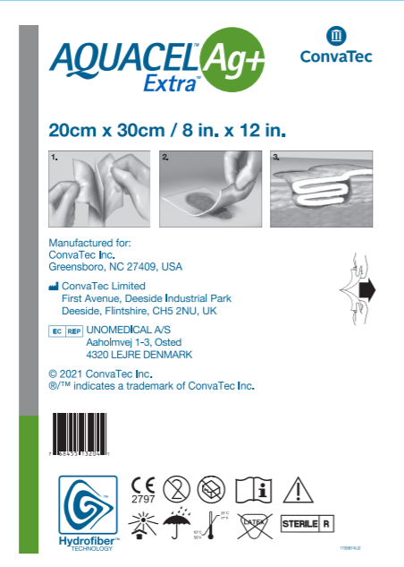

Description of the problem:
ConvaTec are voluntarily initiating a field action for the above-stated product because a complaint has been received for an open seam on the primary packaging (figure 3) and also showing the dressing partially stuck within the seal. This has therefore breached the sterile barrier and made the product unable to be used. Using a non-sterile device on a patient may potentially expose the patient to infectious agents.

Product Identification Procedure:
- Confirmation of Specific Product Code and LOT:
  - This issue is limited to product codes 403711 & 413569.
  - Only the identified product codes and LOTs within this notice may have a potential breach in the sterile barrier packaging.
  - For this reason and to address any potential risk of harm, the affected products 403711 & 413569 from LOTs 0A03126, 9L04131 and 0A01855 should not be used.
  - The only way to identify affected product is by comparing Product code/REF and LOT/Batch number (see Attachment 2) to the product list (see Attachment 1). There is no other discernible difference between affected and unaffected product.

DISTRIBUTOR ACTIONS:
1 | Immediately stop distributing and quarantine all of the affected LOT.
2 | Perform a count of affected product currently in inventory. Complete the enclosed the Corrective Action Response Form and return it to the address on the response form. Return the attached Corrective Action Response Form even if no affected product is in inventory.
3 | You will be reimbursed for the replacement product. Please ensure your account number is correctly identified on the attached Corrective Action Response Form.
4 | If you have distributed this product to other wholesalers, then forward this letter to them and ask that they follow these  Distributor Actions and return the attached Corrective Action Response Form to the address listed on the form.
5 | Send a copy of this market action package to all other consignees: Retailers, if applicable, hospitals and end users. It is extremely important to identify the responsible individual, who is in charge of corrective action activities, at hospital locations. This will make the field action process more effective and eliminate confusion and duplicated effort.
6 | Send a complete list of all consignees to the ConvaTec Coordinator. This information is required to allow ConvaTec to perform corrective action effectiveness checks.

RETAILER ACTIONS:
1 | Immediately stop distributing and quarantine all of the affected LOT.
2 | Perform a count of affected product currently in inventory. Complete the enclosed Corrective Action Response Form and return it to the address on the response form. Return the attached Corrective Action Response Form even if no affected product is in inventory. It is important that you send a copy of the Corrective Action Response Form to your distributor in order to receive reimbursement for the returned product.
3 | Post page one of this Field Safety Corrective Action notice in a conspicuous location in your store.

END USERS (HOSPITALS SERVICES OTHERS):
1 | Immediately stop use and quarantine all the affected LOT.
2 | Perform a count of affected product currently in inventory. Complete the enclosed Corrective Action Response Form and return it to the address on the response form. Return the attached Corrective Action Response Form even if no affected product is in inventory. It is important that you send a copy of the Corrective Action Response Form to your distributor in order to receive reimbursement for the returned product.

Transmission of this Field Safety Notice:
- This notice needs to be passed on to all those who need to be aware within your organisation or to any organisation where the potentially affected devices have been transferred. (As appropriate)
- Please transfer this notice to other organisations on which this action has an impact. (As appropriate)
- Please maintain awareness on this notice and resulting action for an appropriate period to ensure effectiveness of the corrective action.
- Please report all device-related incidents to the manufacturer, distributor or local representative, and the national Competent Authority if appropriate, as this provides important feedback.

ConvaTec is committed to providing quality products and services to our customers and we sincerely apologise
for any inconvenience this notice may cause.

The relevant National Authorities have been advised about this Field Safety Corrective Action.

Authorisation:

Name  Agnieszka M Sikorska-Brzozowska | Title  Senior Regulatory Affairs Manager, Advanced Wound Care | Address  ConvaTec Limited, First Avenue, Deeside Industrial Park, Deeside, CH5 2NU, U.K.
Date |  | Signature
Regional ConvaTec Customer Service Contact:
Belgium:
Tel: +32 (0) 23528956
Email: be.klantenservice@convatec.com

China:
Tel: 021-80308940
Email: jin.wang@convatec.com

Croatia:
Tel:
Email:

Czech Republic:
Tel:
Email:

Denmark:
Tel: (+45) 48167030
Email: customerservicenordic@convatec.com

Estonia:
Tel:
Email:

Finland:
Tel: +358 (0) 20 7659 600
Email: mail.fi@convatec.com

Hungary:
Tel:
Email:

Macedonia:
Tel:
Email:

Norway:
Tel: (+47) 22686095
Email: customerservicenordic@convatec.com

Poland:
Tel:
Email:

Serbia:
Tel:
Email:

Saudi Arabia:
Email: ccc.customerservice@convatec.com

Sweden:
Tel: +46 (0)42 332010
Email: customerservicenordic@convatec.com

Slovakia:
Tel:
Email:

Taiwan:
Tel: +886 0800 886989
Email: Shuchen.Chou@convatec.com

UK:
Tel: + 44 (0) 1244 284882
Email: uk.customerservice@convatec.com

FIELD SAFETY NOTICE DISTRIBUTOR CORRECTIVE ACTION RESPONSE FORM
PLEASE COMPLETE AND RETURN by Fax/Email
Consignee of the device:
Consignee Account No:
Consignee Name:
Consignee Address:

The following products, : AQUACELTM Ag Dressing 20x30cm and AQUACELTM Ag+ EXTRA 20x30cm have been distributed to your facility:
Invoice # | Sales Order # | Product Code / REF No. | SAP Code | LOT No. | Quantity Delivered (boxes of 5)

Distributors (Tick all that apply and give details, where applicable)
 | I confirm the receipt, the reading and understanding of the Field Safety Notice.
 | I have checked my stock and quarantined inventory | Add details to Table 1
 | I have identified customers that received or may have received this device
 | I have attached customer list | Add details to Table 2
 | I have informed the identified customers of this Field Safety Notice | Date sent:
 | I have received confirmation of reply from all identified customers | Attach responses
 | Neither I nor any of my customers has any affected devices in inventory
It is important that your organisation takes the actions detailed in the FSN and confirms that you have received the FSN. Your organisation's reply is the evidence we need to monitor the progress of the corrective actions.

Table 1. Quarantined Inventory: Record quantity (boxes of 5) for each LOT to be returned.

LOT No. | Units on Hand

Table 2. Customer List: Please provide details of affected: AQUACELTM Ag Dressing 20x30cm and AQUACELTM Ag+ EXTRA 20x30cm product that were distributed to your customers.

Customer Name | Product Code / REF No. | SAP Code | LOT No. | Quantity (boxes of 5)

FORM Completed and Returned From:
Name (CAPITAL LETTERS):
Position:
Company Name:
Address:
Phone No:
Signature:
Date (dd/mmm/yyyy):

FIELD SAFETY NOTICE CUSTOMER CORRECTIVE ACTION RESPONSE FORM
PLEASE COMPLETE AND RETURN by Fax/Email
Consignee of the device:
Consignee Account No:
Consignee Name:
Consignee Address:

The following products, : AQUACELTM Ag Dressing 20x30cm and AQUACELTM Ag+ EXTRA 20x30cm product have been distributed to your facility:
Invoice # | Sales Order # | Product Code / REF No. | SAP Code | LOT No. | Quantity Delivered (boxes of 5)

Customer action undertaken on behalf of Healthcare Organisation (Tick all that apply)
 | I confirm receipt of the Field Safety Notice and that I read and understand its content.
 | I performed all actions requested by the FSN.
 | The information and required actions have been brought to the attention of all relevant users and executed.
 | I have checked my stock and quarantined inventory | Add details to Table 1
 | No affected devices are available for return
It is important that your organisation takes the actions detailed in the FSN and confirms that you have received the FSN. Your organisation's reply is the evidence we need to monitor the progress of the corrective actions.

Table 1. Quarantined Inventory: Record quantity (boxes of 5) for each LOT to be returned.

 | LOT No. | Units on Hand
FORM Completed and Returned From:
Name
(CAPITAL LETTERS):
Position:
Company Name:
Address:
Phone No:
Signature:
Date (dd/mmm/yyyy):

ICC Code | SAP Code | Product Description | Lot Number | Date of Mfg | Market Unit Qty
403711 | 1186118 | AQUACELTM Ag Dressing 20x30cm (1x5pk) | 0A03126 | 20 Jan 2020 | 959 packs = 4795 dressing
403711 | 1186113 | AQUACELTM Ag Dressing 20x30cm (1x5pk) | 9L04131 | 02 Dec 2019 | 1440 packs = 7200  dressings
413569 | 1708965 | AQUACELTM AG+ EXTRA 20X30CM(1X5PK) | 0A01855 | 15th Jan 2020 | 1800 packs = 9000  dressings
Attachment 1 Product Details:

Attachment 2 Examples of Labelling and Affected Product:
The shipper labelling will include the product REF/ICC code and the product LOT number (see example to the right). | Shipper Label:  LOT Number  ICC Code  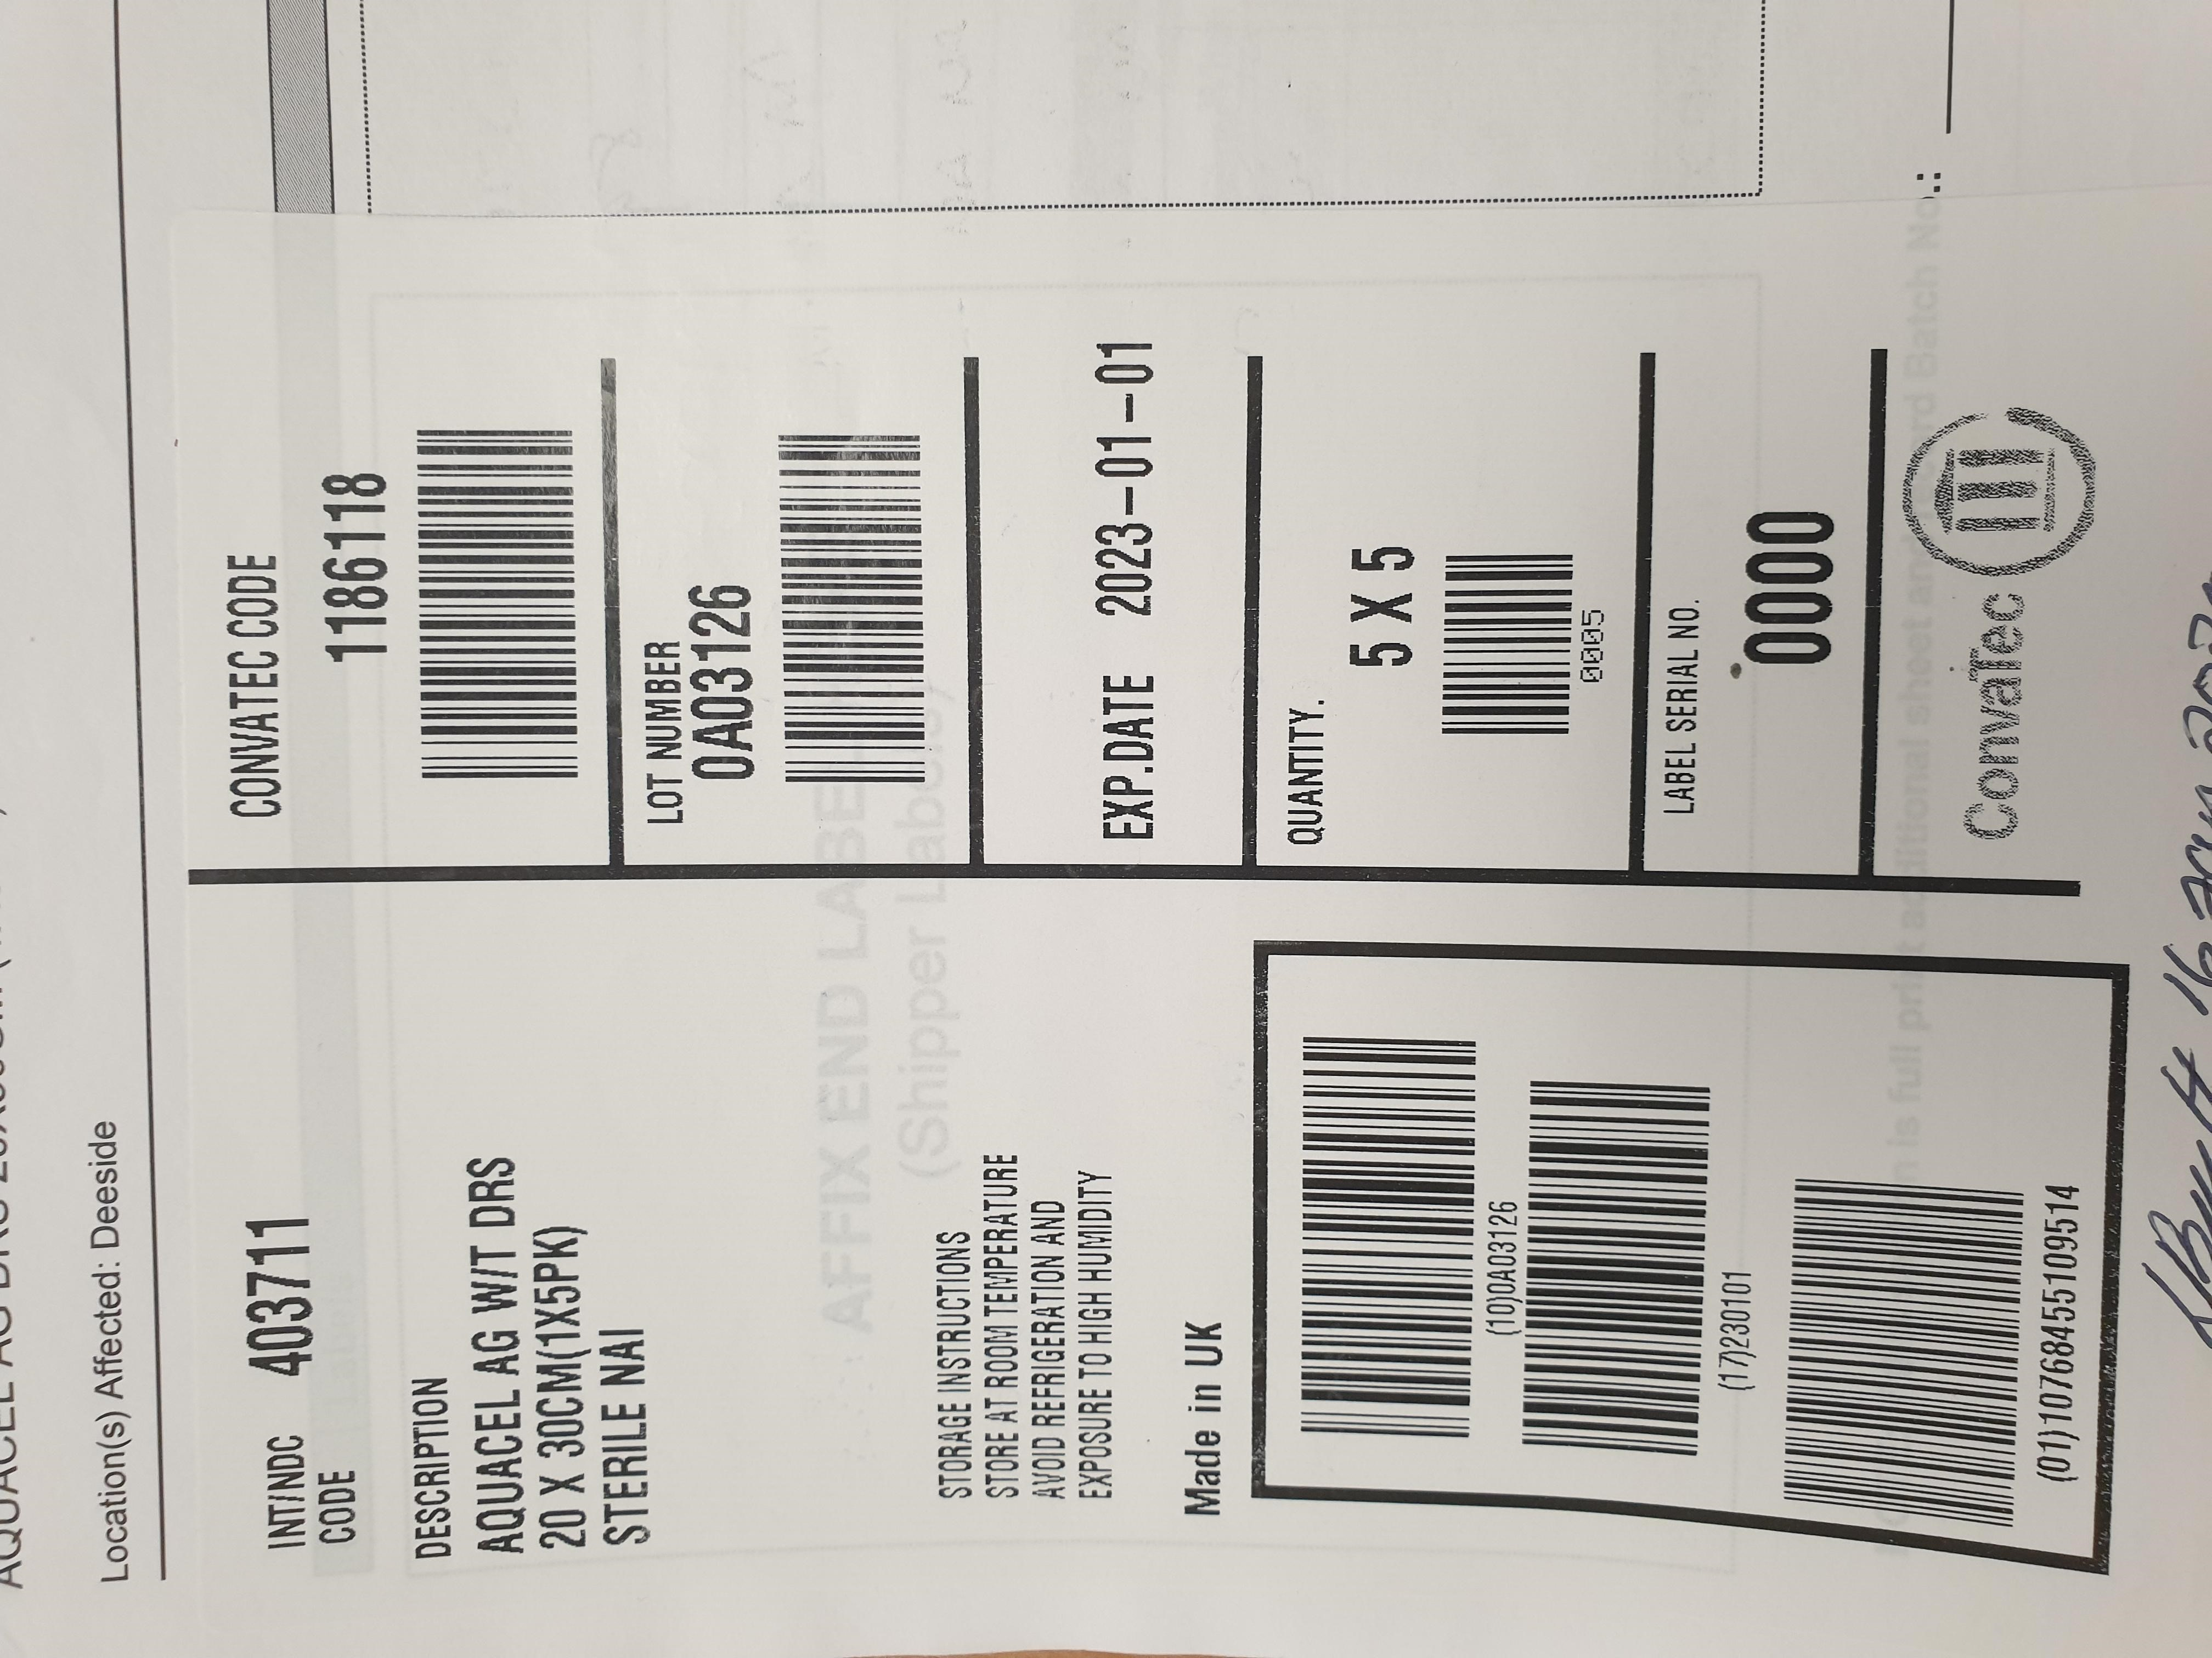
The market unit labelling will include the product REF/ICC code and the product LOT number (see example to the right). | 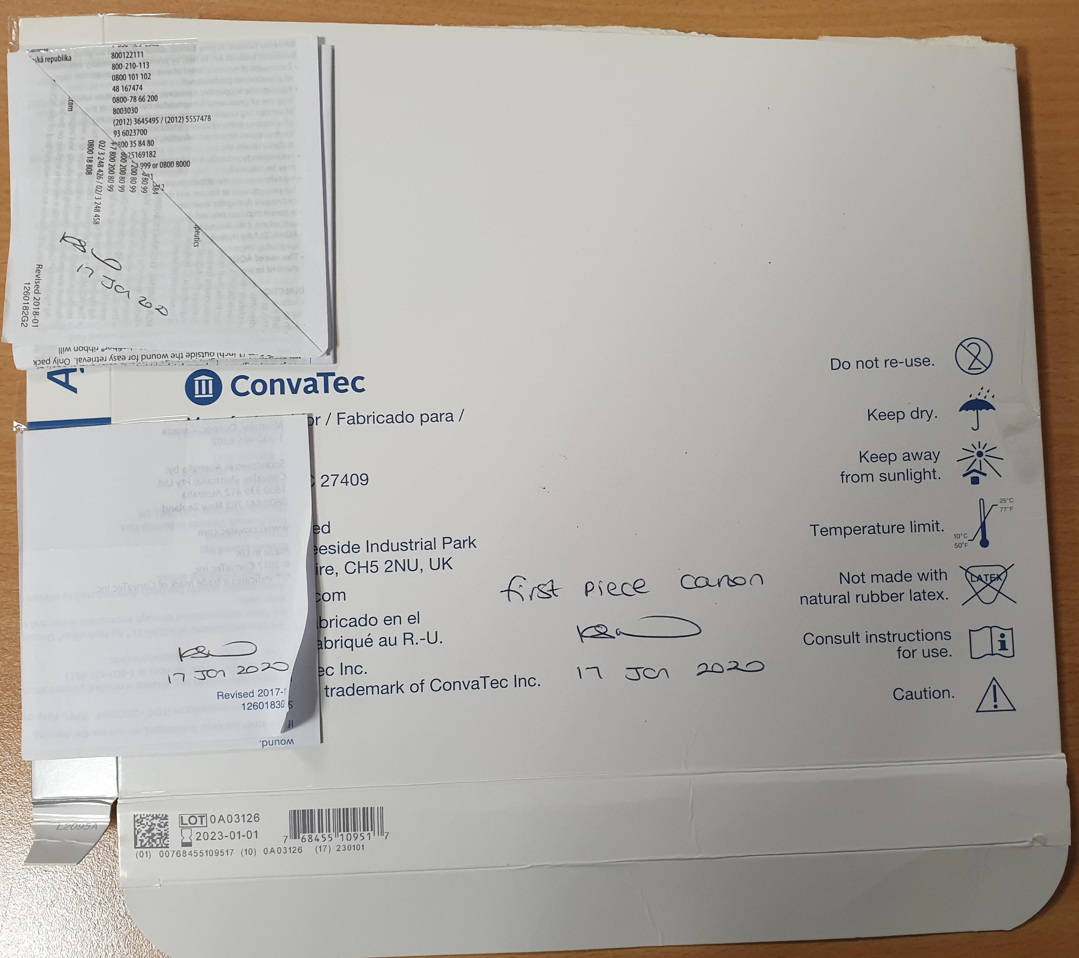  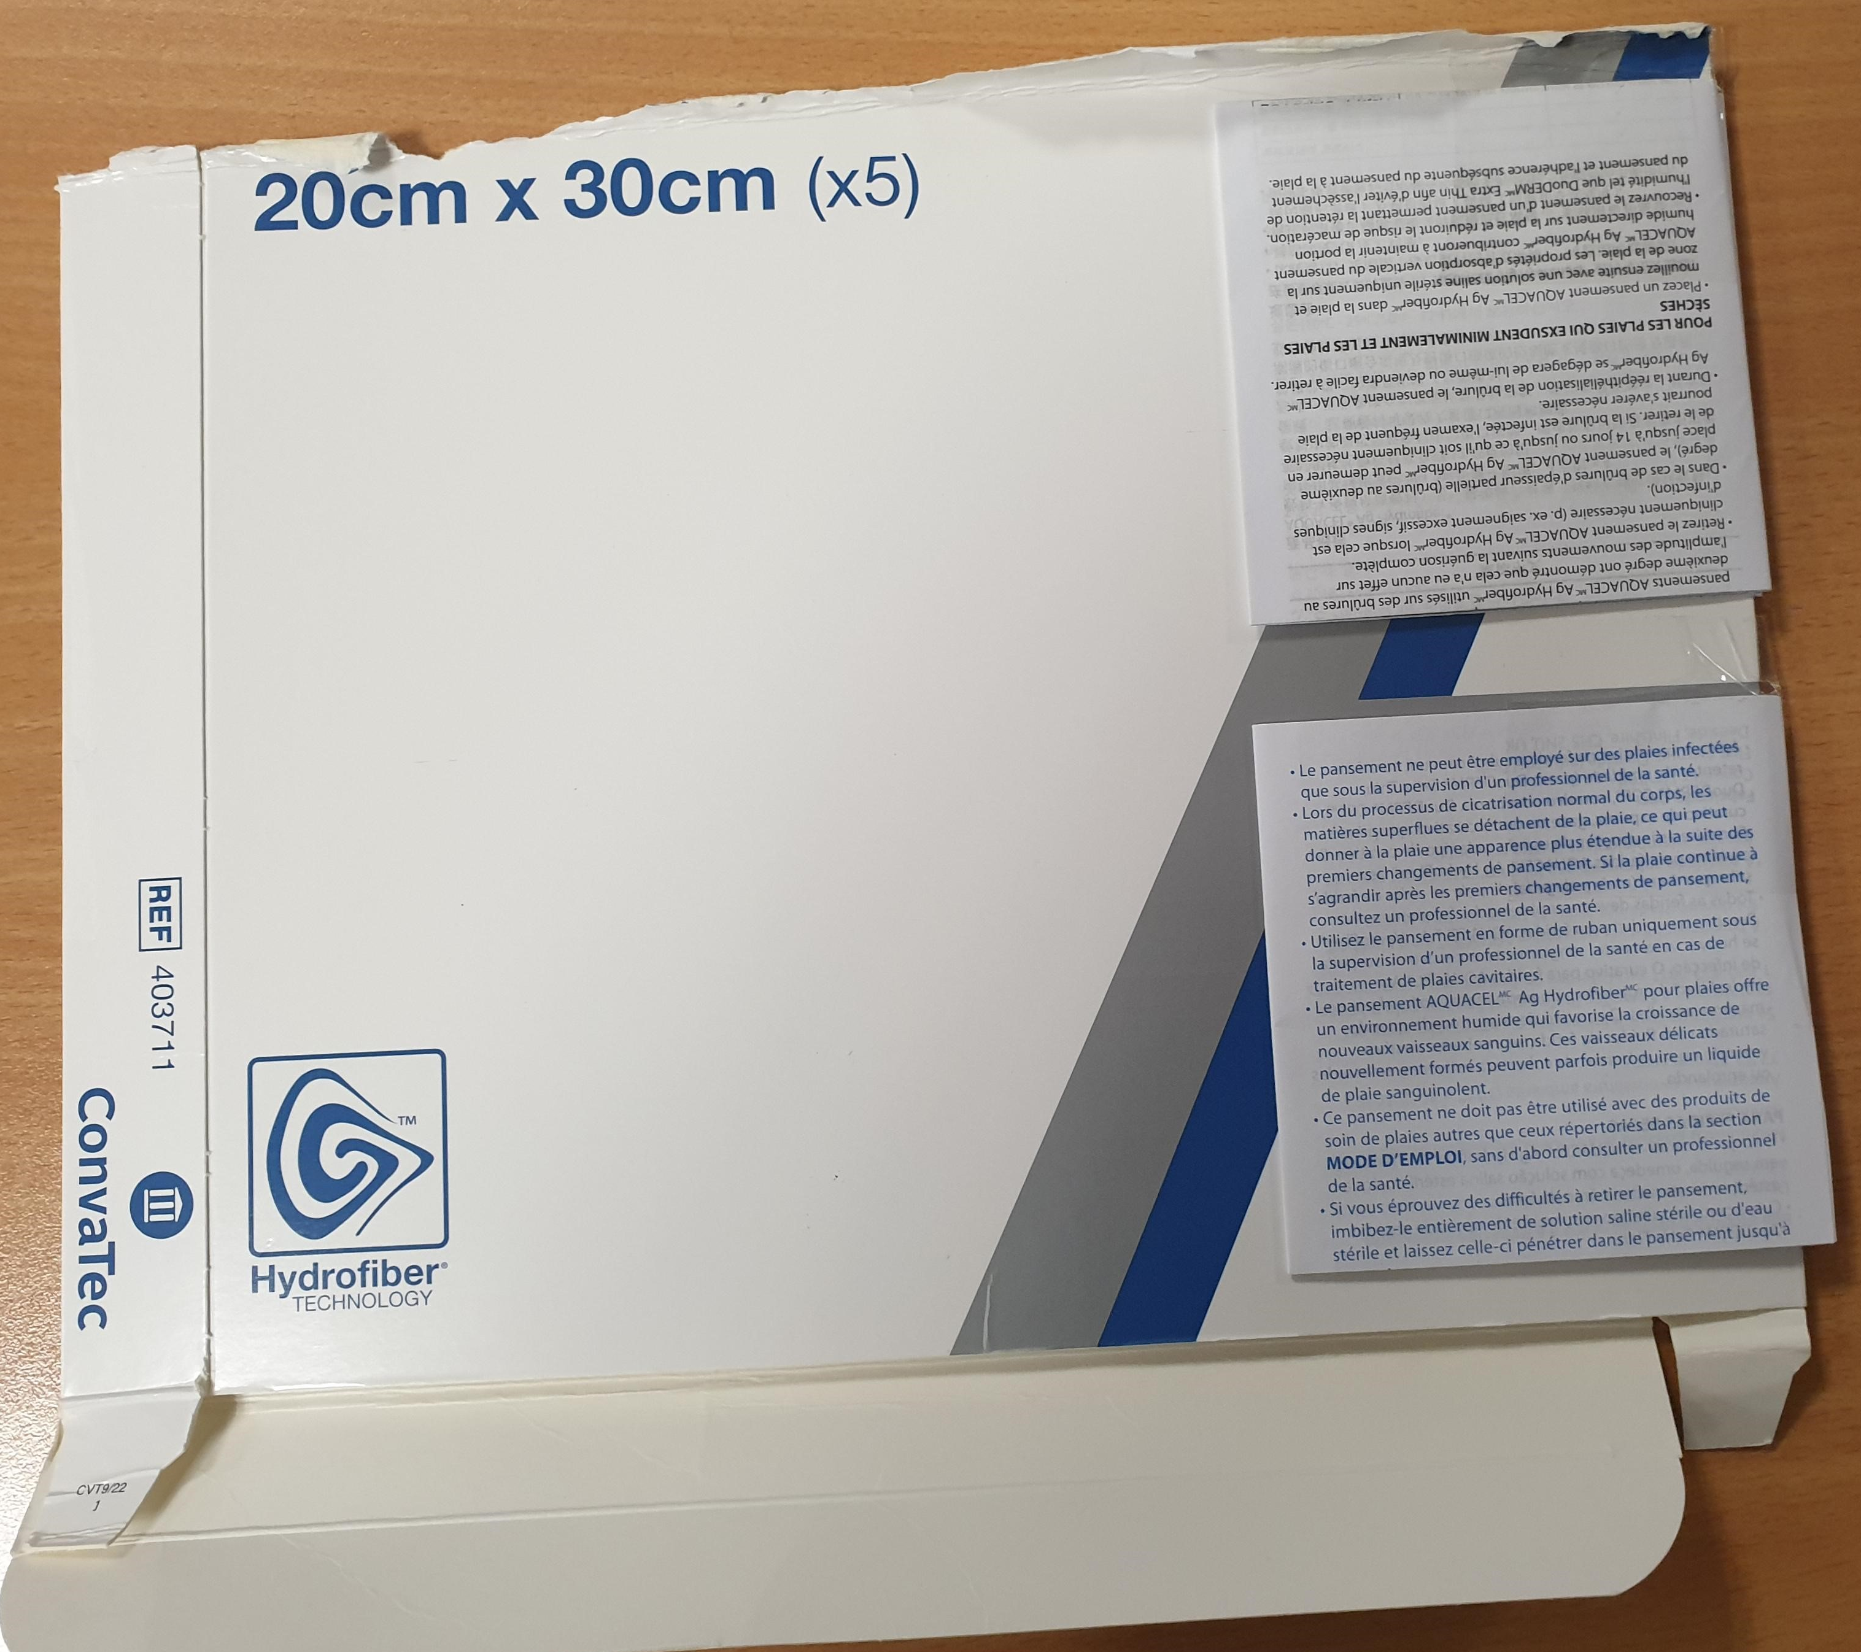  Front of Carton: Back of Carton:  ICC Code  LOT Number  Foil Packaging:  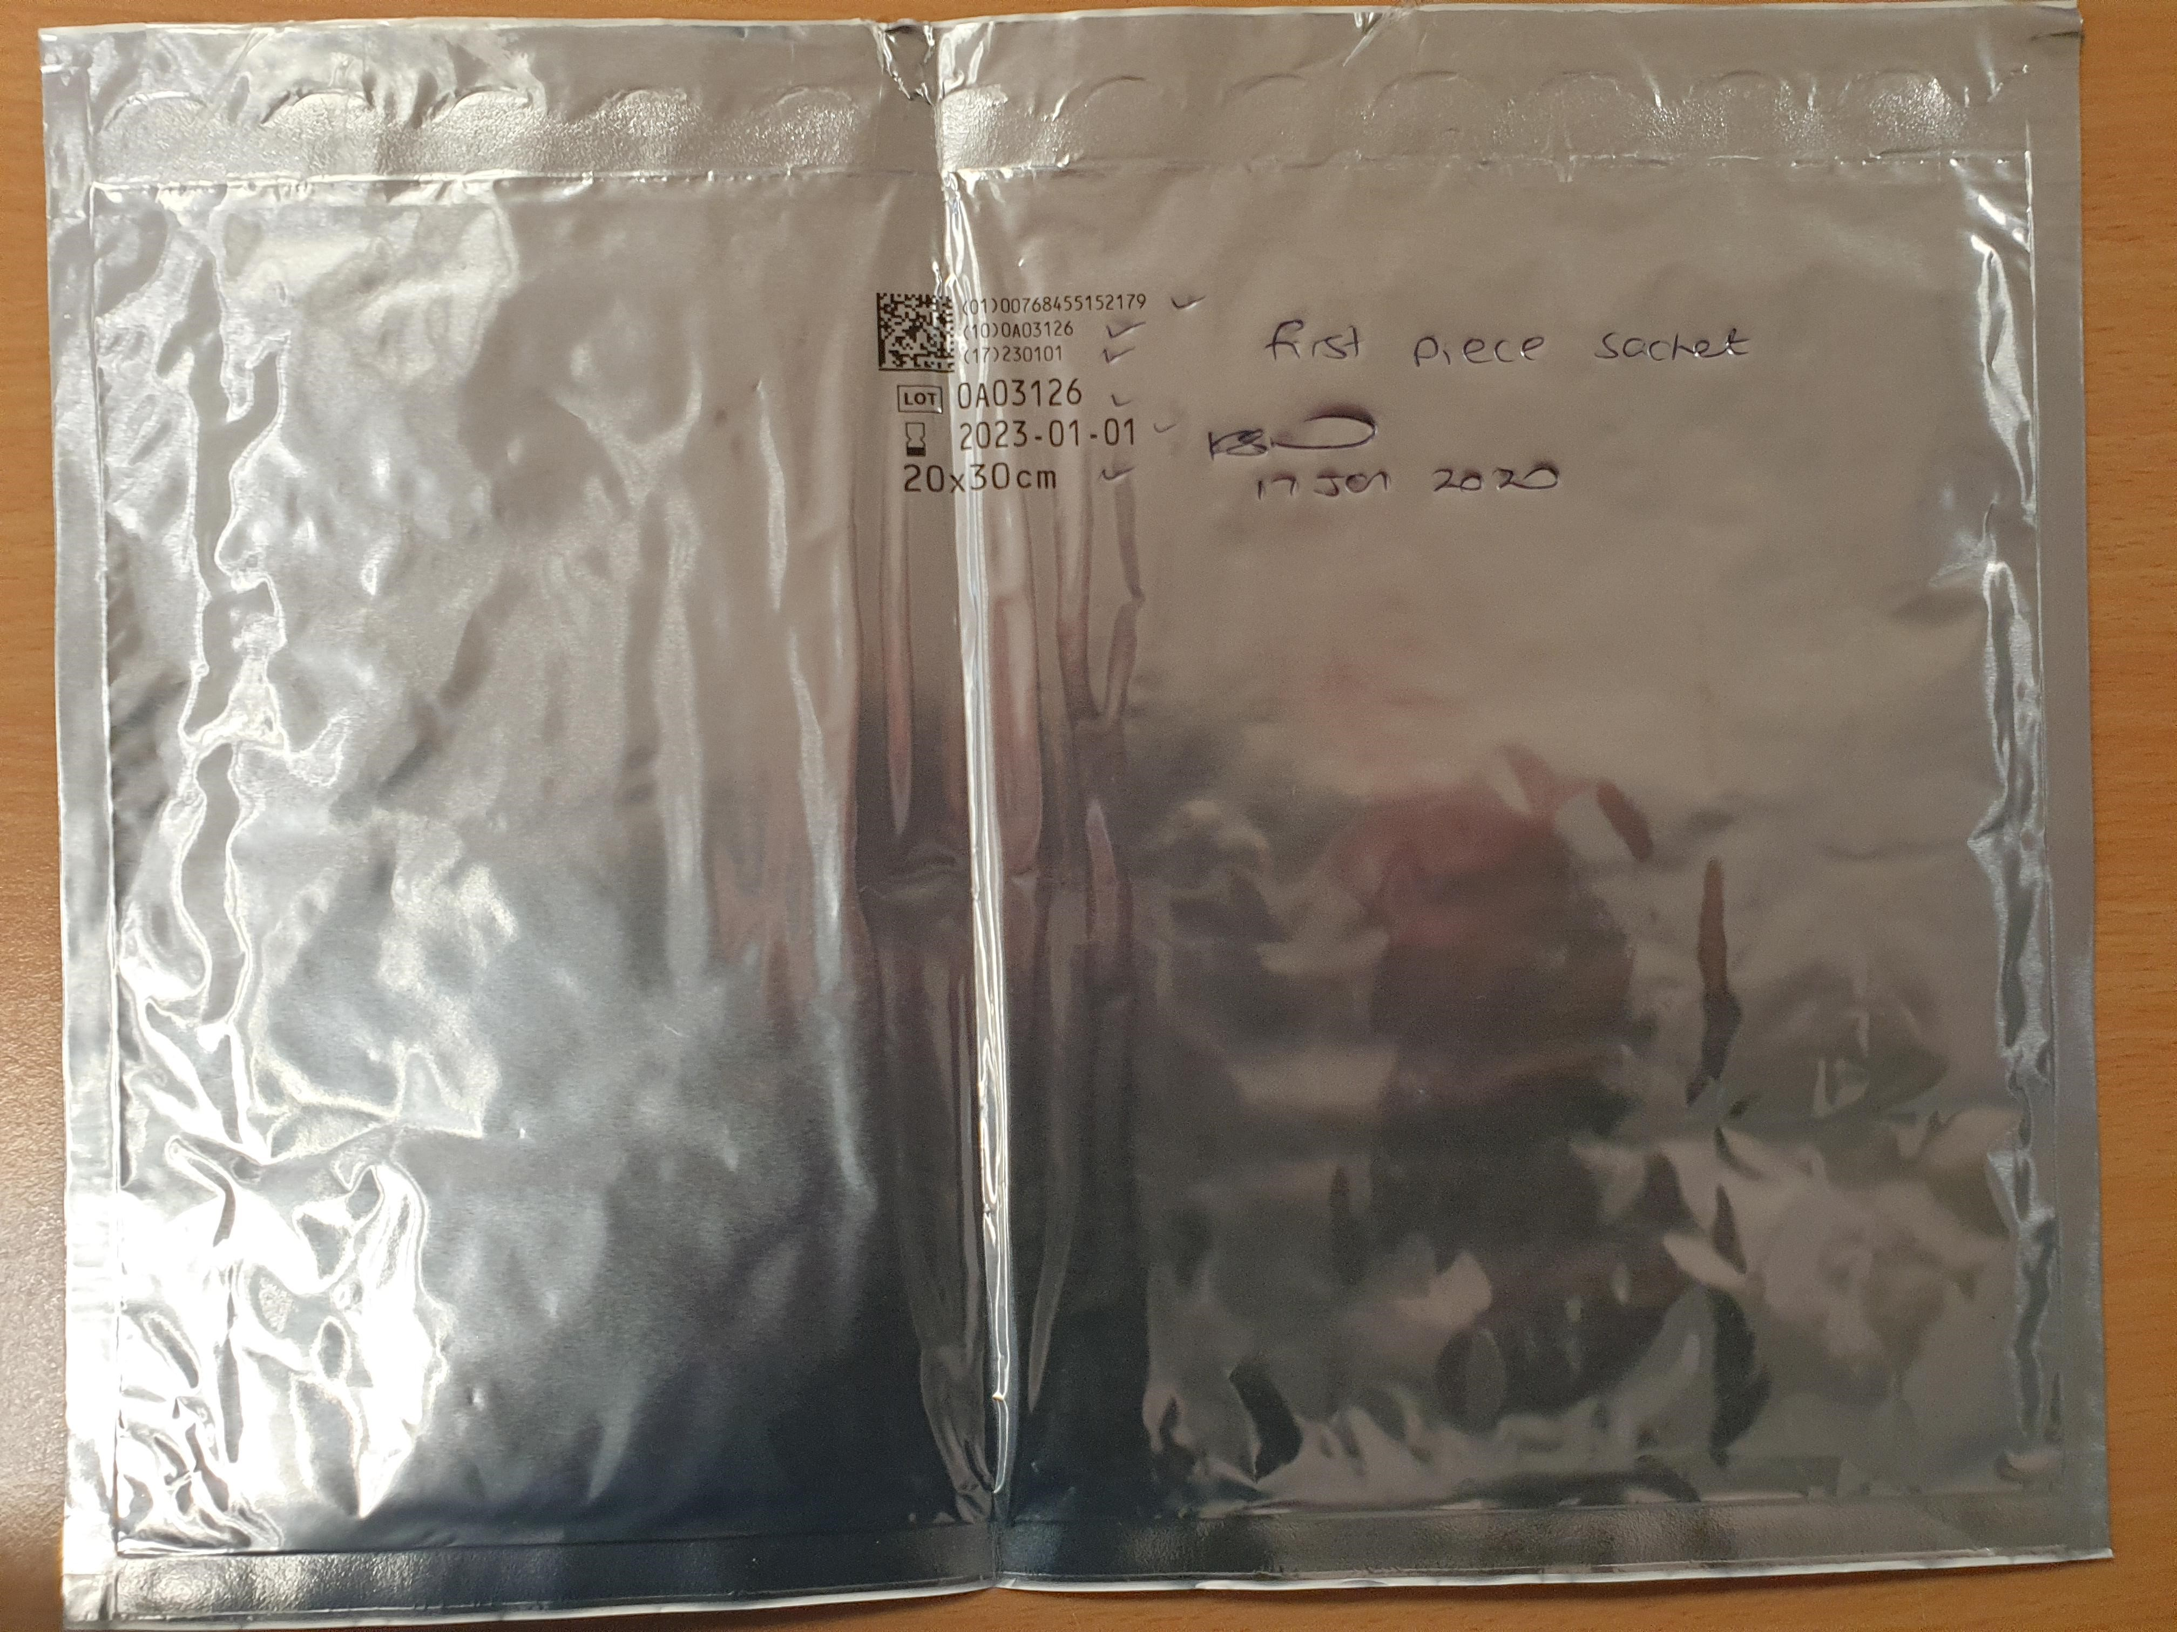  LOT Number

