September 7, 2022

Commercial Name: MitraClip™ G4 Clip Delivery System, MitraClip™ NTR/XTR Clip Delivery System, TriClipTM NT/XT Clip Delivery System, and TriClipTM G4 Clip Delivery System (reference Appendix A for model numbers)
FSCA-Identifier: Clip Delivery System September 7, 2022
Manufacturer: Abbott Vascular Santa Clara, CA (SRN#: US-MF-000003850)
Type of Action: Advisory Regarding the Use of the Device

Attention: Healthcare Professional, Implanting Physician

Abbott is sharing information about the use of the MitraClip™ and TriClipTM Delivery System(s). Abbott has observed an increase in complaints regarding Clip locking malfunctions. This communication is to bring awareness, share the actions Abbott is taking, and emphasize the relevant steps of the Instructions for Use (IFU) to aid in optimal function of the Clip locking mechanism.

Your current inventory of product may be used with the guidance described in the attached materials. There is no need to return any product to Abbott.

Description and Identification of the Incidence
The increased rate of reports is for clips failing to “Establish Final Arm Angle” (EFAA) and for events of “Clip Opening While Locked” (COWL).
- EFAA is a procedural step where the user intentionally attempts to open a locked Clip to verify that the locking mechanism is engaged. EFAA steps occur during device preparation and prior to Clip deployment. An EFAA failure occurs if the Clip opens during this verification step.
- COWL describes when the Clip Arm angle increases post-deployment. In these cases, users observe a slippage in the lock, resulting in an Arm angle greater than 10 degrees from the angle observed at deployment. This change in arm angle after deployment can be identified through fluoroscopy (see example in Appendix A, Figure 1).

Table 1 shows the estimated rate of EFAA Failure and COWL reports as a function of MitraClipTM and TriClipTM use.

Table 1 Global Rate of MitraClipTM and TriClipTM reported events over estimated clip usage
Global Rate | EFAA Failure Rate | COWL Rate
February 2021 – January 2022 | 0.50% | 0.27%
February 2022 - July 2022 | 0.79% | 0.48%

Potential Patient Risk
Table 2 shows the outcomes and associated rates of EFAA failure and COWL events observed during MitraClipTM and TriClipTM procedures.

Table 2: Observed rates during a MitraClip™ and TriClipTM procedure (February 2022 – July 2022)
Patient Outcomes | Observed EFAA failure | Observed COWL
No consequence to patient | 0.72% of total implants  (91.4% of EFAA cases) | 0.30% of total implants  (62.3% of COWL cases)
Intraprocedural MR/TR recurrence | 0.06% of total implants  (7.5% of EFAA cases) | 0.17% of total implants  (35.1% of COWL cases)
Other | 0.01% of total implants  (1.1% of EFAA cases) | 0.01% of total implants  (2.6% of COWL cases)
¹Depending on clinical status, treatments may include medical management, usage of an additional clip, catheter snaring technique or vascular surgery to remove embolized clip, or non-urgent surgical valve replacement/repair.

In Mitral Regurgitation (MR) or Tricuspid Regurgitation (TR) patients with multiple comorbidities and who are not surgical candidates, an unsuccessful MitraClip or TriClip procedure, recurrence of severe MR/TR, device embolization, or tissue injury may lead to hospitalization, worsening congestive heart failure, cardiogenic shock, or death. However, while there has been a recent increase in reported EFAA failure and COWL events, the acute procedural success rate remains consistent with historical data. Further, EFAA failure or COWL most often results in no adverse patient outcomes. COWL may lead to less MR/TR reduction, which is often treated with the use of one or more additional clips. There is a low incidence of required additional interventions, and:
- Zero (0) immediate open surgical conversions have been observed as a result of EFAA/COWL events.
- 0.33% of EFAA/COWL events have resulted in non-urgent open surgical conversions based on clinical decisions by the treating physician, such as, to treat significant residual MR/TR.

The MitraClip™ and TriClipTM therapy continues to provide a significant benefit to patients, and performance remains within the anticipated risk levels for these therapies.

Clip Mechanism and What to Do if the Issue Occurs
When the Clip is locked, the locking mechanism is designed to more fully engage as the Grippers push down on the Clip Arms. The constant force applied by the Grippers secures the leaflets within the Clip. During a COWL event, the lock slips as the Clip Arms open by a given degree. In any case where significant residual MR/TR is observed after Clip deployment, a second Clip should be considered and implanted in accordance with the IFU.

What Action Abbott is Asking You to Take
- Please read through this customer letter and share this information with personnel associated with MitraClip procedures in your organization.
- Please continue to follow the steps of the IFU (eifu.abbottvascular.com) as summarized in Appendix A. It details the most relevant steps to aid in optimal function of the Clip locking mechanism, thereby reducing the probability of EFAA failure and COWL to occur.
- Complete and return the provided Acknowledgement Form.
- If you have transferred MitraClip products to other centers, inform those centers of this notice.
- Report any product incidents, regardless of procedure or patient outcome, to Abbott. When available, return any product related to an incident to Abbott for investigation.

Action Abbott is Taking
- Abbott has identified a contributing cause of EFAA/COWL events as a change in the material properties of one of the Clip locking components. Abbott is working on producing new lots with updated manufacturing processing and raw material to mitigate EFAA/COWL events.
- It is also known that certain use conditions can contribute to EFAA/ COWL events. As such, Abbott is using this communication to emphasize the most relevant sections of the IFU that can reduce occurrence, referenced in Appendix A.

Thank you for your attention to this matter. Abbott is committed to providing high-quality products and partnering with you to ensure the safety of each patient. Please address any questions you may have with your local Abbott representative or Customer Service Department at <insert regional phone number>.

Sincerely,

<signature of country manager>
<printed name>
<title>

Appendix A:

Example of imaging
An example of a Clip opening by 17 degrees is shown in Figure 1.
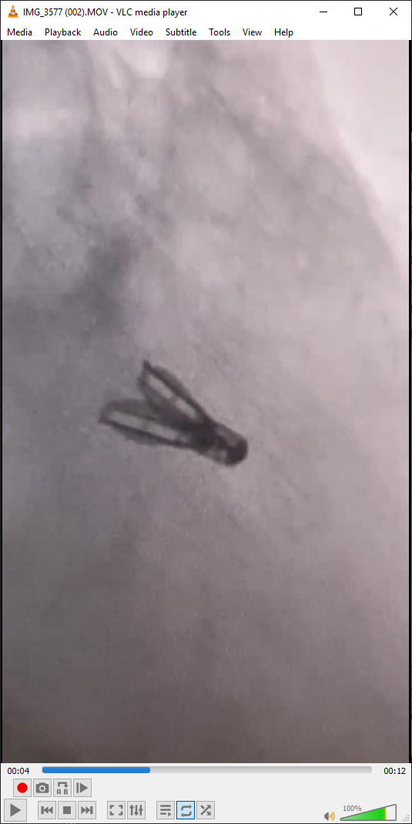
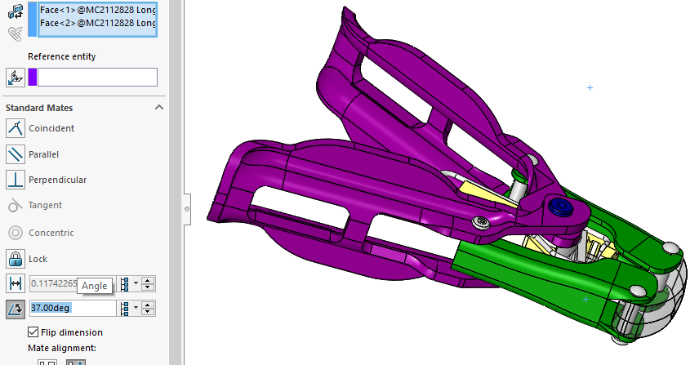
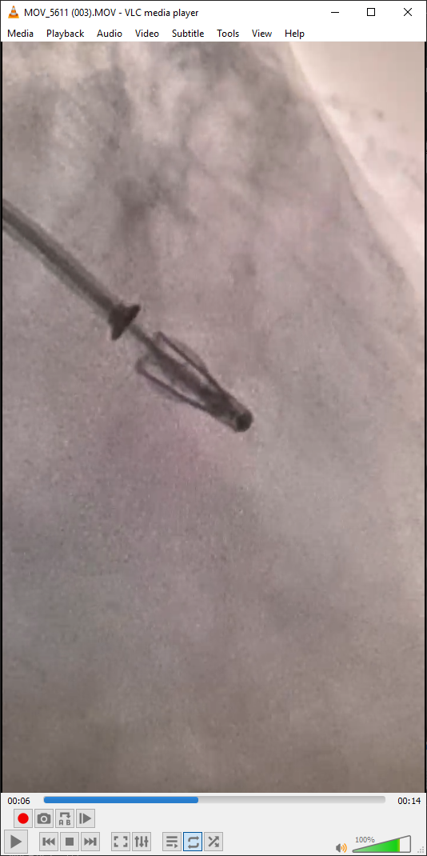
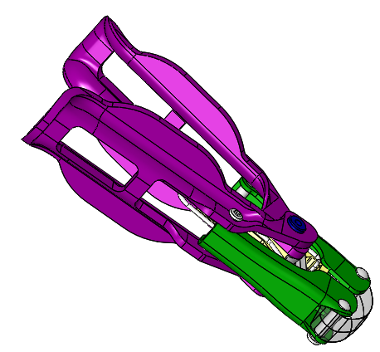
POST-DEPLOYMENT
CLIP ARM ANGLE = 37 DEGREES
PRE-DEPLOYMENT
CLIP ARM ANGLE = 20 DEGREES
POST-DEPLOYMENT
CLIP ARM ANGLE = 37°
PRE-DEPLOYMENT
CLIP ARM ANGLE = 20°
CAD MODEL OVERLAYS
FLUOROSCOPIC IMAGES
Opened Arm Angle
37 degrees (+17 degrees)
Initial Arm Angle
20 degrees

Figure 1: Fluoroscopic imaging of a Clip opening while locked (COWL) at deployment (left) with CAD model overlay super-imposed (right)

Steps relevant to Clip lock mechanism
The following information consist of the relevant steps of the Instructions for Use (IFU) and physician training materials with additional explanations to aid in optimal function of the Clip locking mechanism.

- Unlocking the Clip During Device Preparation and Intraprocedural
- Rotate the Lock Lever outward and then retract the lever until the mark on the lever is fully exposed. Rotate the Lock Lever inward to engage the lever.
- Warning: DO NOT retract the lever forcefully. It may result in the inability to lock or unlock the Clip.
- If Clip does not unlock and Clips Arms fail to open visibly, use the following techniques:
  - Stop and return the Arm Positioner to Neutral. Retract the Lock Lever farther, then turn the Arm Positioner farther in the “Close” direction before turning in the ‘Open’ direction. Advance the lock lever just enough so that the mark on the lever is still fully exposed.
  - Turn the Arm Positioner to Neutral, then incrementally iterate the amount of Arm Positioner rotation in the “Close” direction followed by rotation in the “Open” direction. Iterate until Clip opens or until it is no longer possible to rotate the Arm Positioner in the “Close” direction. Advance the lock lever just enough so that the mark on the lever is still fully exposed.
  - Turn the Arm Positioner to Neutral, iterate the amount of Lock Lever retraction past the mark in 5 mm increments, and rotate the Arm Positioner fully in the “Close” direction, before rotating in the “Open” direction, until Clip opens. Advance the lock lever just enough so that the mark on the lever is still fully exposed.

Explanation: Forceful retraction of the Lock Lever involves retraction of the Lock Lever beyond the mark on the Lock Lever. This can inadvertently cause Harness deformation which can prevent the lock from functioning properly.

- System Positioning
- Initial Positioning in the Left Atrium: Position the Clip centrally over the valve with respect to anterior-posterior and medial-lateral directions. In the Right Atrium, position the Clip centrally over the valve with respect to the aortic-posterior and septal-lateral directions. Align the Clip so the DC Shaft is perpendicular to the valve plane.
- Final system positioning: Raise the Grippers, Unlock the Clip and Open the Clip Arms to approximately 180 degrees. Adjust the system to reposition the Clip as necessary, rotate the DC handle to align the Clip Arms perpendicular to the line of coaptation.
- Warning: Do confirm that the Clip Arms are perpendicular to the line of coaptation. Failure to do so may result in loss of leaflet capture and insertion.

Explanation: If the Clip Arms are not perpendicular to the line of coaptation, or the Delivery Catheter (DC) is not perpendicular to the valve plane during leaflet grasping, asymmetric tension on the leaflets may result in Clip rotation-post deployment and/or potential increase in MR/TR. The Clip rotation could be interpreted as a change in Clip Arm angle.

- Locking Sequence (After Satisfactory Leaflet Grasp)
- Close the Clip until the Clip Arm Angle is approximately 60 degrees. Release tension on the DC and secure the DC Fastener.
- After verifying leaflet insertion and confirming the grasp is satisfactory, lock the Clip and slowly close the Clip just until the leaflets are coapted and MR/TR is sufficiently reduced.

Explanation: After leaflet capture and insertion confirmation, locking the Clip at Clip Arm angle >60 degrees is to ensure that there is enough room for the harness to center in a locked configuration. Adequate leaflet insertion is necessary to maintain the leaflets within the Clip.

- Establish Final Arm Angle (EFAA)
- With the Lock Lever fully advanced, and the Arm Positioner to Neutral (note the orientation of the blue line on the Arm Positioner), turn the Arm Positioner 1 turn in the “Open” direction (confirm blue line has returned to the original orientation). The Clip Arms may open slightly (~5°) and then remain in a stable position.
- If continued opening of the Clip Arms is noted, reconfirm that the Lock Lever is completely advanced. Close the Clip Arms, and Establish Final Arm Angle.
- Warning: DO NOT turn the Arm Positioner more than 1 turn in the “Open” direction from neutral. Failure to stop turning the Arm Positioner at 1 turn in the “Open” direction past neutral may result in Clip opening or device damage which could cause the Clip to become non-functional and lead to embolization and / or conversion to surgical intervention.
- If Failure to Establish Final Arm Angle continues and the Clip lock does not hold, do not continue with deployment steps and replace the CDS.

- Lock Line Removal
- Pre-deployment Clip Assessment: Confirm DC Handle is secure, perform EFAA, turn the Arm Positioner to the “closed” side of the neutral position
- Deployment step 1: Lock line removal: While holding the ends of the Lock Line remove the Lock Lever Cap and “O” ring. Unwrap the two ends of the Lock Line in a counterclockwise direction. Separate the ends of the Lock Line and remove the plastic cover from the lines so that no twists or knots are present. Grasp one of the free ends of the Lock Line, confirm the line moves freely, and slowly remove the Lock Line. Pull the Lock Line coaxial to the Lock Lever. If resistance is noted, stop and pull on the other free end to remove the Lock Line.
- Perform EFAA.

Explanation: When the Lock Line is removed, the locking mechanism may be disrupted and can cause the Clip Arms to open. Turning the Arm Positioner to the “close” side of neutral pulls the Clip Arms in the closed direction, which prevents the Clip Arm from opening during Lock Line removal. Therefore, post-Lock Line removal EFAA confirms the Clip did not unlock during Lock Line removal.

MitraClip™ G4 Clip Delivery System and MitraClip™ NTR/XTR Clip Delivery System Model Numbers
All MitraClip lot numbers are within scope of this Correction Notice.

Part Number | Product Description | GTN/UDI
CDS0702-NT | MitraClip G4 Clip Delivery System NT CE | 08717648230950
CDS0702-NTW | MitraClip G4 Clip Delivery System NTW CE | 08717648230974
CDS0702-XT | MitraClip G4 Clip Delivery System XT CE | 08717648230998
CDS0702-XTW | MitraClip G4 Clip Delivery System XTW CE | 08717648231018
CDS0704-NT | MitraClip G4 CDS NT REPAIR-MR Clinical | 08717648234576
CDS0704-NTW | MitraClip G4 CDS NTW REPAIR-MR Clinical | 08717648234590
CDS0704-XT | MitraClip G4 CDS XT REPAIR-MR Clinical | 08717648234583
CDS0704-XTW | MitraClip G4 CDS XTW REPAIR-MR Clinical | 08717648234606
CDS0705-NT | MitraClip G4 Clip Delivery Sys NT ROW | 08717648288616
CDS0705-NTW | MitraClip G4 Clip Delivery Sys NTW ROW | 08717648288630
CDS0705-XT | MitraClip G4 Clip Delivery Sys XT ROW | 08717648288623
CDS0705-XTW | MitraClip G4 Clip Delivery Sys XTW ROW | 08717648288647
CDS0701-NT | MitraClip G4 Clip Delivery System NT US | 08717648230943
CDS0701-NTW | MitraClip G4 Clip Delivery System NTW US | 08717648230967
CDS0701-XT | MitraClip G4 Clip Delivery System XT US | 08717648230981
CDS0701-XTW | MitraClip G4 Clip Delivery System XTW US | 08717648231001
CDS0601-NTR | MitraClip NTR Clip Delivery System US | 08717648226342
CDS0601-XTR | MitraClip XTR Clip Delivery System US | 08717648226366
CDS0602-NTR | MitraClip NTR Clip Delivery System CE | 08717648226359
CDS0602-XTR | MitraClip XTR Clip Delivery System CE | 08717648226373

TriClip™ G4 Delivery System and TriClip™ NT/XT Clip Delivery System Model Numbers
All TriClip lot numbers are within scope of this Correction Notice.

Part Number | Product Description | GTN/UDI
TCDS0202-NT | TriClip NT Clip Delivery Sys CE | 08717648229985
TCDS0202-XT | TriClip XT Clip Delivery Sys CE | 08717648229978
TCDS0205-NT | TriClip NT Clip Delivery Sys ROW | 08717648288692
TCDS0205-XT | TriClip XT Clip Delivery Sys ROW | 08717648288708
TCDS0302-NT | TriClip G4 NT Delivery System CE | 08717648334238
TCDS0302-NTW | TriClip G4 NTW Delivery System CE | 08717648334252
TCDS0302-XT | TriClip G4 XT Delivery System CE | 08717648334245
TCDS0302-XTW | TriClip G4 XTW Delivery System CE | 08717648334269
TCDS0305-NT | TriClip G4 NT Delivery System ROW | 08717648334313
TCDS0305-NTW | TriClip G4 NTW Delivery System ROW | 08717648334337
TCDS0305-XT | TriClip G4 XT Delivery System ROW | 08717648334320
TCDS0305-XTW | TriClip G4 XTW Delivery System ROW | 08717648334344

September 7, 2022

Commercial Name: MitraClip™ G4 Clip Delivery System, MitraClip™ NTR/XTR Clip Delivery System, TriClipTM NT/XT Clip Delivery System, and TriClipTM G4 Clip Delivery System
FSCA-Identifier: Clip Delivery System September 7, 2022
Manufacturer: Abbott Vascular Santa Clara, CA
Type of Action: Advisory Regarding the Use of the Device

Acknowledgement Form

Customer Account # _________________________________________
Account Name _________________________________________
Address _________________________________________
_________________________________________
(Information required for regulatory effectiveness check)

After reviewing the Correction Notice, complete and sign using indelible ink, and return this form to Abbott per the instructions below.

By signing below, I acknowledge:

I am a treating physician, catheterization lab management, or risk management administrator.

I have received and read the September 7, 2022 MitraClip and TriClip Delivery System(s) Correction Notice.

And, I have shared this information with other personnel associated with MitraClip procedures in my organization and any other centers to whom we may have further transferred these products.

________________________________ ____________________________________

Name (print) Job Title (print)

________________________________ ____________________________________

Signature Date

This form is to be returned to Abbott
Scan and email this form to <insert regional email> or fax to <insert regional fax number>.

Acute Procedural Success is defined as cases with successful implantation resulting in MR that is 2+ or less as reported at the time of the procedure.

