URGENT FIELD SAFETY NOTICE

MEDICAL DEVICE RECALL
Select VERITAS™ Advanced Infusion Packs

September XX, 2022

Dear Johnson & Johnson Vision Customer:

RE: Voluntary Recall of 55 Lots of VERITAS™ Advanced Infusion Packs (Part Number[P/N]: VRT-AI)

Johnson & Johnson Surgical Vision, Inc. (JJSV) is voluntarily initiating a recall of select VERITAS™ Advanced Infusion Packs (P/N: VRT-AI) (this “Action”). This Action only affects VERITAS™ Advanced Infusion Packs with lot numbers listed on page 5 as identified (the “VERITAS™ Packs”) in this notice. The VERITAS™ Packs lot number is displayed on the lid label (see page 3 for label example).

Reason for Recall:
Johnson & Johnson Vision has initiated this Action due to the potential for the irrigation luer to crack or break. A crack or break of the irrigation luer could lead to reduced irrigation pressure during surgery, associated with an unstable anterior chamber. This hazard could result in patient harm such as, but not limited to, capsule tear. Additionally, there could be a delay in surgery if a leakage is noticed during or prior to surgery and the pack must be switched out. As of August 29, 2022, there have been forty-one (41) product complaints, including one (1) adverse event, associated with this issue.

Required Actions to be Taken:
You are receiving this notice because our records indicate that you received VERITAS™ Packs impacted by this Action. Please take the following actions:

- Identify if any of your inventory contains VERITAS™ Packs with a lot number listed on page 5.
- Immediately discontinue using and remove from your inventory all affected VERITAS™ Packs. No other VERITAS™ Advanced Infusion Packs are affected by this recall.
- Complete the attached Customer Reply Form (on page 4). We require this information for reconciliation purposes with regulatory agencies, even if you have no inventory.

If you have product to be returned:

- Complete the Customer Reply Form, noting the lot numbers of the VERITAS™ Packs.
- Contact Customer Support at [Insert regional contact number] to obtain a RGA number and arrange the product return.
- Email Customer Reply Form to [insert regional email address] within 3 business days of receipt of this letter.
- Return the affected product as soon as possible. A credit will be issued upon receipt of the customer reply form and product.
If you do not have product to be returned:

- Complete and return the Customer Reply Form and email to [insert regional email address] within 3 business days of receipt of this letter.

- Share this notice with anyone within your organization that needs to be informed and to any organization where the potentially affected products have been transferred.

If you have product complaints or adverse events to report regarding the use of these VERITAS™ Packs, please inform Johnson & Johnson Vision by calling [Insert regional contact number]. If you do report a complaint, please provide the VERITAS™ Packs lot number and, if a patient was involved, the date of surgery, a description of the event and patient outcome.

[National Competent Authorities have been notified of this action.]

We apologize for any inconvenience this causes you and your patients. The health and safety of patients is our number one priority at Johnson & Johnson Vision and we thank you for your assistance in expediting the return of this product. If you have questions or concerns with regards to this notification, please contact [Insert regional contact number].

Sincerely,

[insert regional QA contact name and title]
Johnson & Johnson Surgical Vision, Inc.

VERITAS™ Pack Lid Label Example

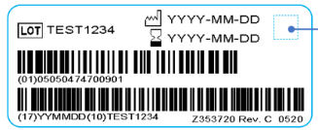
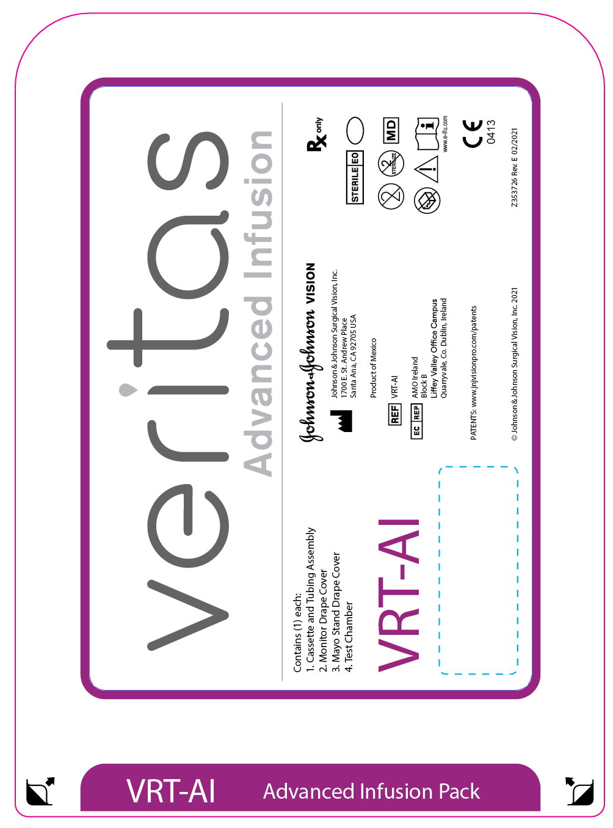
Example: Part Number location
Example: Lot Number location

Product RECALL Letter Dated September XX, 2022

2022 VERITAS™ ADVANCED INFUSION PACKS (P/N: VRT-AI) RECALL CUSTOMER REPLY FORM

Please complete and return immediately EVEN IF YOU HAVE NO STOCK via email: [insert regional email address].

Please place an “X” in one of the boxes below.

 | All affected products have been used or discarded. No product to return.
 | Product(s) was (were) previously returned to JJSV.
 | - If product was returned, please provide the RGA#: | _______________________________
 | We are returning affected products.
 | - If product will be returned, please provide the RGA#: | _______________________________
 | - Indicate the Lot Number(s) and Quantity of the product to be returned below.

Lot Number | Quantity of VERITAS™ Advanced Infusion Packs (P/N: VRT-AI) to be Returned

JJV Account Number:
Account Name:
Address:
City, State, Zip Code:
Country:
Telephone Number:

Person completing this form acknowledges the receipt and understanding of the actions, as stated in the Product Recall letter:
Name: (print)
Title/Position:
Signature:
Date:

List of fifty-five (55) impacted lots of VERITAS™ Advanced Infusion Packs (P/N: VRT-AI)

Lot Number
60316112
60330206
60330248
60341105
60341106
60341107
60342401
60343412
60343413
60351691
60352993
60352994
60352995
60352996
60352997
60352998
60352999
60353436
60353443
60353444
60353445
60353446
60353447
60353448
60353449
60353450
60353451
60353452
Lot Number
60353453
60353772
60353811
60353812
60353813
60353814
60353815
60354982
60355023
60355024
60355025
60355026
60355027
60355330
60355335
60355972
60360065
60360066
60362043
60362044
60362435
60362436
60364566
60369607
60369608
60369609
60381689

