Fisher & Paykel Healthcare Pty Ltd
19-31 King Street
Nunawading, Melbourne
Victoria, 3131 Australia
PO BOX 159 Mitcham,
Victoria 3132, Australia

Telephone: +61-3-9871 4900
Facsimile: +61-3-9871 4998
Website: www.Fphcare.com

DD MMM YYYY

[Appropriate personnel title e.g. Chief Executive Officer]
[Company Address]

Attention: [Head of appropriate department e.g. Chief Biomedical Engineer, Clinical Investigator, Director of Nursing, Risk Manager, Home Care Company / DME (Durable Medical Equipment)]

Urgent Medical Device Recall
Fisher & Paykel Healthcare PT101XX Airvo 2 and PT100XX myAirvo 2

F&P Recall Reference: FA-2024-001

Fisher & Paykel Healthcare (F&P) is initiating a voluntary limited recall of batches of Airvo 2 and myAirvo 2 devices manufactured before 14 August 2017.

AFFECTED PRODUCT DETAILS

PRODUCT NAME | PART NUMBER / MODEL | SERIAL NUMBER RANGE
Airvo 2 | PT101XX  Note: XX represents the various model number country suffixes. | 120521YYYYYY - 170813YYYYYY
myAirvo 2 | PT100XX  Note: XX represents the various model number country suffixes.

DEVICE USE

Airvo 2 and myAirvo 2 devices are used to deliver high flow respiratory therapy to patients. The Airvo 2 and myAirvo 2 devices are not intended for life support. Patient monitoring is required at all times.

REASON FOR RECALL

The reason for the voluntary limited recall relates to a speaker configuration in Airvo 2 and myAirvo 2 devices manufactured before 14 August 2017.

The speaker in the Airvo 2 and myAirvo 2 devices is intended to provide the user with auditory alerts and alarms under certain conditions. In devices manufactured before 14 August 2017, the speaker configuration may result in distorted, intermittent or inaudible alarm sound levels.

This does not affect the therapy delivered by the Airvo 2 and myAirvo 2 device. The device will otherwise perform as intended. The visual alarm on the display will continue to function and notify the user of the alarm state. However, in the absence of an audible alarm, if there is an interruption to therapy, a patient may experience oxygen desaturation.

Beginning 14 August 2017, a new speaker configuration from a different supplier was implemented into the manufacturing of Airvo 2 and myAirvo 2 devices.

Airvo 2 and myAirvo 2 devices manufactured on or after 14 August 2017 are not subject to this recall.

ACTIONS BEING TAKEN BY F&P

F&P is taking steps to remove and replace products affected by the recall (Affected Product).

Affected Product will be [removed and returned to your local F&P Regional Office].

ACTIONS REQUIRED FROM YOU

Please follow the steps below to support this recall.

Actions for Affected Product in your inventory

Step 1
- Identify any Affected Product in your inventory by checking the Reference (REF) and Serial Number (SN) on the product label underneath the base of the unit or the label on the box (see Figure 1).
- Place the Affected Product in quarantine.

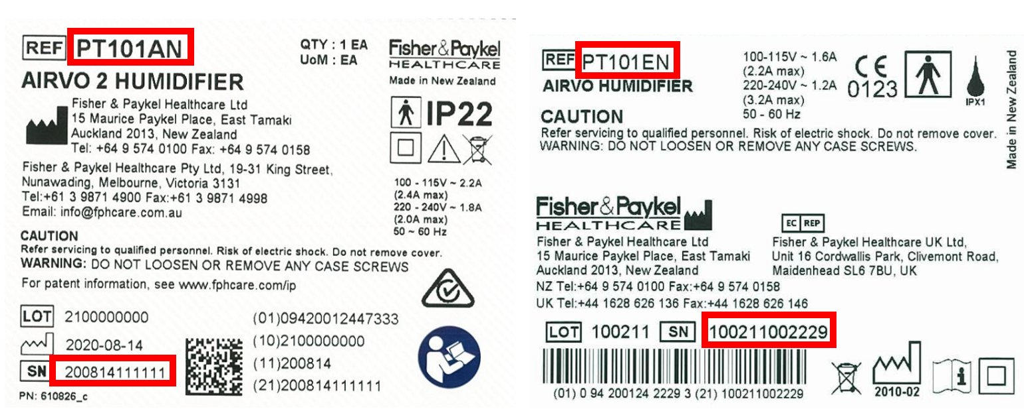
Figure 1: Examples of Airvo 2 labels

Step 2
Complete Section A – Inspection of Stock on the Medical Device Recall Response Form attached and return as specified on the form.

Step 3
Contact your F&P representative [insert contact details] OR F&P Regional Office [insert contact details] to arrange the collection of the Affected Product and to obtain replacement product.

INFORMING OTHERS OF THIS RECALL

Please inform anyone within your organisation who needs to be aware of this recall.

If you have distributed Affected Products to any other customer or organisation, please notify them within 5 business days of receiving this notice.

If you have any questions, please contact your F&P representative OR F&P Regional Office via email at [email@Fphcare.com] or directly at [enter telephone details].

Yours sincerely,

[Signature]
[Insert sponsor name, position details]

