PRODUCT
RECALL
Urgent Field Safety Notice

Q-Link 13, Adapter kit LikoScale, and LIKO UNO 102 EE Mobile lift
FA-2025-017
Manufacturer: Liko AB (Single Registration Number: SE-MF-000001404)
Type of Action: Recall

Follow-up Communication to June XX, 2025, Product Recall. (To Be Adapted Locally)

November XX, 2025 (to be adapted locally)

Dear Sir/Madam: (to be adapted locally)

On June XX, 2025 (to be adapted locally), Baxter issued an Urgent Product Recall letter for the Q-link 13 component due to customer reports of improper attachment.

The new Q-link mobile components are now available for distribution, and Baxter is advising customers to request replacement units and discard the recalled Q-link 13 components. Please see the Actions to be Taken by Customers section below for further details.

Affected Product (to be adapted locally)

Product  Code | Product  Description | Products Used in Conjunction with Q-Link 13
3156509 | Q-link 13 components manufactured from 8/27/2013 to 2/27/2025 | Uno 102 EE mobile lift - product code 2010004
3156509 |  | Viking L mobile lift - product codes 2040014, 2040034, 2040044
3156509 |  | Viking XL mobile lift - product codes 2040013, 2040033, 2040043
3156509 |  | Viking M mobile lift - product codes 2040015, 2040035, 2040045, 2040045A
3156509 |  | Viking S mobile lift - product code 2040006
3156509 |  | Viking XS mobile lift - product code 2040007
3156509 |  | LikoLight mobile lift - product code 2030001
 |  | Products Used in Conjunction with LikoScale Adapter Kit
3156232 | LikoScale adapter kits manufactured from 8/26/2013 to 2/27/2025 | LikoScale 200 accessory - product code 3156225
3156232 |  | LikoScale 350 accessory - product code 3156228
3156232 |  | LikoScale 400 accessory - product code 3156226

Hazard Involved
The recalled Q-link 13 component allows for an improper attachment (false latching) of the quick-release hook used on sling bars and other accessories. This could result in a critical injury from a patient fall, as the incompletely latched component may initially bear weight but can loosen from the Q-link, resulting in detachment and drop. There were three reports of serious injury, and one death associated with a fall/drop due to incorrect attachment of the sling bar involving the recalled Q-link 13 component.

Actions to be Taken by Customers

- Scan the QR code at Fig.1 or navigate to https://forms.office.com/r/ejrrFW061F to access the online form for requesting Q-link mobile replacements kits (part number: 3156510FA). Please enter your Customer Account Number on the online form.
Fig. 1
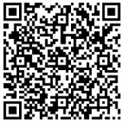
Customer Account Number: XXXXXX (To Be Adapted Locally).
This form serves as a request for replacement parts. For any special requests or questions, please use the following email address: fa_2025_017_orders@baxter.com

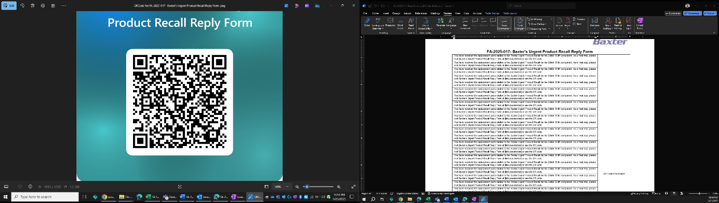
- After receiving the replacements parts, follow the instructions to install the Q-link mobile components. Once installation is complete, scan the QR code below or navigate to https://forms.office.com/r/rEYGddBgPZ to confirm the new Q-link mobile components have been installed and the recalled Q-link 13 components have been discarded. Please enter the customer account number provided on the enclosed reply instruction sheet.

- If you have not previously responded and acknowledged this field action, please complete the enclosed customer reply form and return it to Baxter by either faxing it to (insert local contact information) or scanning and e-mailing it to (insert local contact information) or sending it by post to (insert local contact information), even if you don’t have any inventory. Returning the customer reply form promptly will confirm your receipt of this notification and prevent you from receiving repeat notices.

- If you distributed this product to other facilities or departments within your institution, please forward a copy of this communication to them.

- If you purchased this product from a distributor, please contact your supplier to arrange for replacement of the affected product. Please note that the Baxter customer reply form is not applicable. If a reply form is provided by your distributor or wholesaler, please return it to the supplier according to their instructions.

- If you are a dealer, wholesaler, distributor/reseller, or original equipment manufacturer (OEM) that distributed any affected product to other facilities, please notify your customers of this Recall in accordance with your customary procedures.

Further Information and Support
For general questions regarding this communication or any product issue you are experiencing, contact Baxter at (insert local contact information), between the hours of (insert local information).

The local Ministry of Health (MOH) has been notified of this action. (to be adapted locally)

We apologize for any inconvenience this may cause you and your staff.

Sincerely,

Name (to be adapted locally)
Title (to be adapted locally)
Baxter Healthcare Corporation (to be adapted locally)

Enclosure: Baxter Customer Reply Form
Urgent Product Recall letter dated June XX, 2025 (to be adapted locally)

