Registering with CESP (hma.eu)

Select New Delivery File
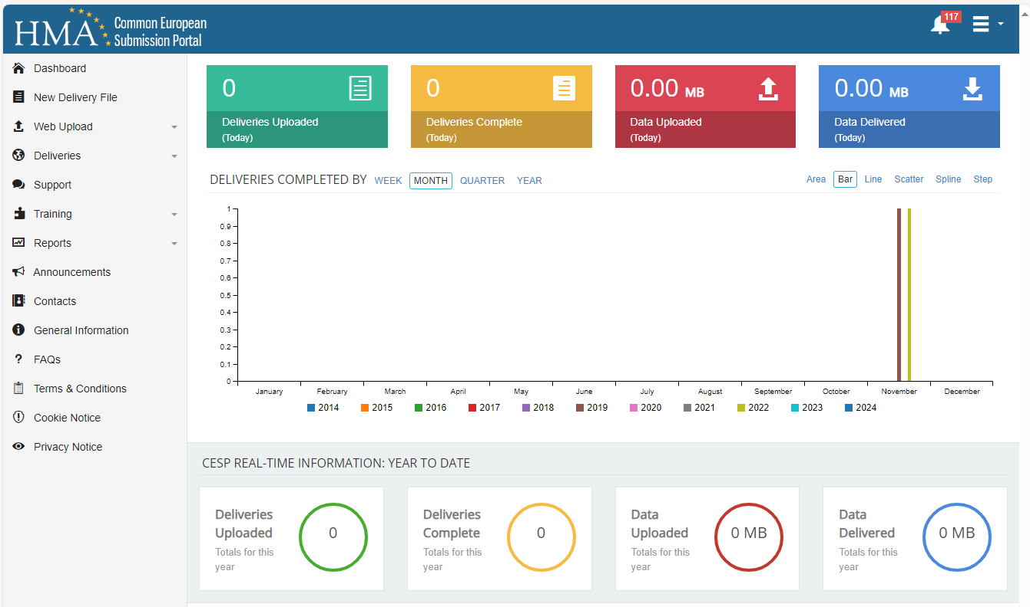

Step 1: Select “Parallel Import” as “Regulatory Activity” from the drop-down menu. It is important that the “Comment” field is used to state the type of application submitted e.g. “Underretning om ændring – Product name – marketing authorisation numer(s)” (please refer to “Submission options for applications regarding parallel import and parallel trade” on the Danish Medicines Agency website):
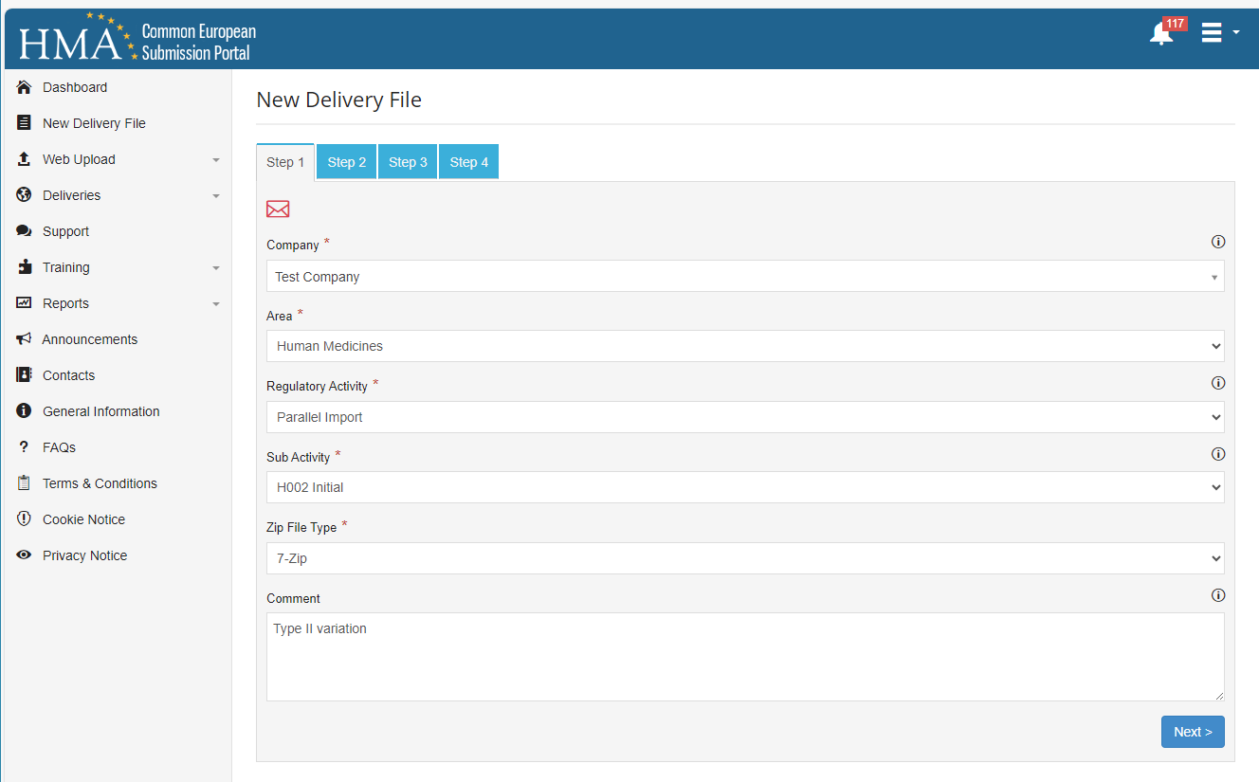

Step 2. Select “National” and “Other eSubmission Type” and “No”:
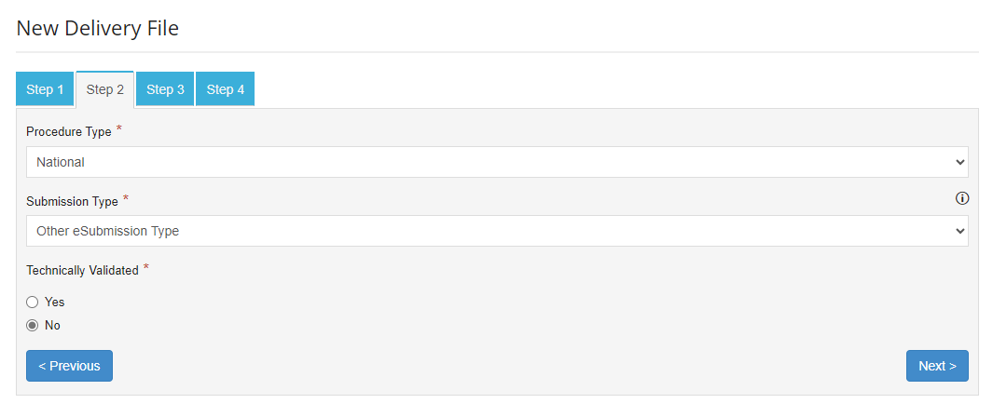
Step 3. Select “Lægemiddelstyrelsen”:
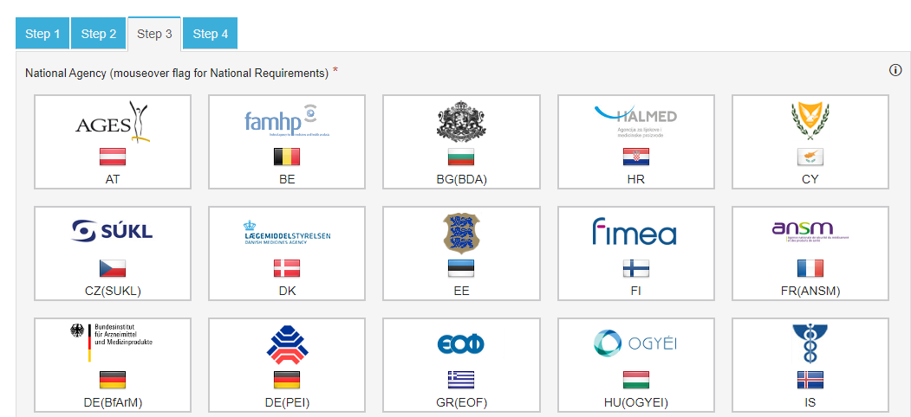

Step 4. It is possible to add other e-mail addresses. Complete with marketing authorisation number and medicinal product name in “MAA Number” and “Product Name”:
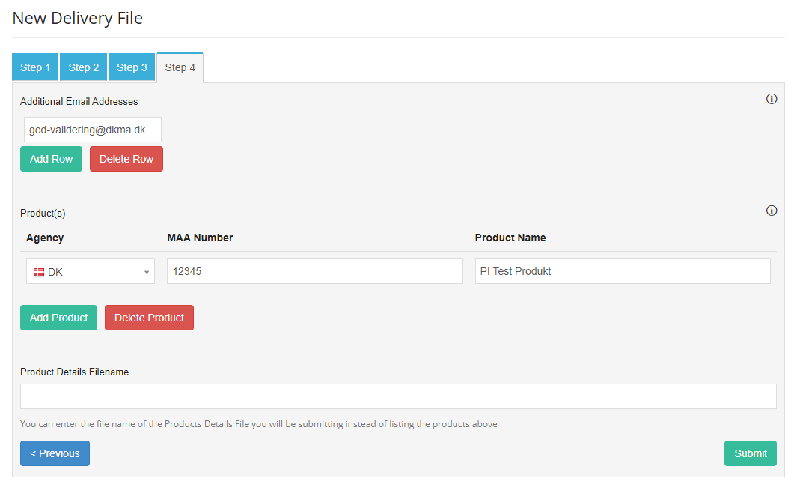
Press “Submit”. Download Delivery File:
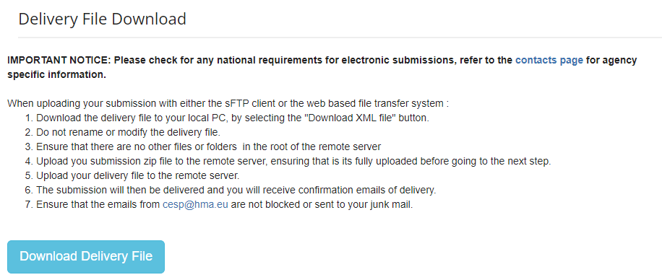
Then choose “Integrated Upload” under “Web Upload”.
Upload zipped folder with files first, and then “Delivery File” with the unique CESP-number, e.g. CESP_Submission_1234567.

You will receive a delivery notification from the CESP-portal and may see your deliveries in the Dashboard.
Frequently asked questions are available here: FAQ (hma.eu).

