DKMAnet

User manual



**Introduction**

The DKMAnet user manual has a dual purpose: It is an introductory guide to the system and a mini reference book for the use of DKMAnet.

The Danish Medicines Agency's support team is available to answer any questions or queries at [dkmanet@dkma.dk](mailto:dkmanet@dkma.dk)

**Reading instructions**

First, the general terms, icons and structure are described, followed by detailed descriptions of the different functions.

Functions that are only relevant to company administrators are described in a separate chapter at the end of the manual.

When sections of the pages are described in the text below, such sections will be marked on the screenshot at the start of the chapter.

All designations and functions in the manual are marked by quotation marks ("), e.g. "Overview".

When actions are described, such as selection of a main function and subsequent selection of a sub-function and maybe a tab, these will be separated by the > character. Example: "Overview" > "Prices and assortment" > "Notifications". This means that you must select "Overview", click "Prices and assortment" and finally select the "Notifications" tab to view the section described.

**Before using DKMAnet**

In order to start using DKMAnet, the following conditions must be met.

**Working at a foreign company**

Security administrators, company administrators and users working for companies that do not have a Danish company registration number must be issued a Closed User Group (CUG) certificate (in Danish LBC) from the Danish Medicines Agency. Order a Closed User Group certificate [here](http://laegemiddelstyrelsen.dk/en/reimbursement/prices/~/media/7A50C4BFE2E5490B90588F918BEC43EF.ashx).

**Working at a Danish company**

Users that are working at a Danish company with a Danish company registration number must order their

certificates at Nets danID. Information on digital certificates may be found on the [Nets DanID website](https://www.nemid.nu/dk-en/about_nemid/business/nemid_employee_certificate).

**For all certificates**

Please note that all certificates are personal, and that an employee signature must be issued for each user in the company. Depending on your browser and type of certificate, it may be necessary to allow popup windows during installation. Depending on how your browser handles PDF files, allowing popups may also be necessary in order to read certain notifications on DKMAnet.

**How to gain access to DKMAnet**

Your company must appoint a security administrator. The form for appointing a security administrator can be found [here](http://laegemiddelstyrelsen.dk/en/reimbursement/prices/~/media/274197ACCAD842D889C15F090E37F2BA.ashx). Based on his form the Danish Medicines Agency will then create a security account for your company. The security administrator is responsible for creating all company administrators and company users. Please contact the Danish Medicines Agency in case of questions or for further information at [dkmanet@dkma.dk](mailto:dkmanet@dkma.dk).

**Contents**

1 Terms, shortcut keys and icons 1

1.1 Terms 1

1.2 Icons 2

2 Functions in DKMAnet 3

3 Configuration of DKMAnet 4

4 General functions 6

4.1 Searching 6

4.2 Refresh 6

4.3 Guideline 6

4.4 Show as PDF – printouts and receipts 6

4.5 Print/Save function 7

4.6 Contact 7

4.7 Log out 7

4.8 To company profile 7

4.9 Deadline for notification 7

4.10 The time at the Danish Medicines Agency 7

4.11 Correspondence 7

4.12 Status 8

4.12.1 Price period: Current …………………………………………………….8

4.12.2 Price period: Upcoming 8

4.12.3 Price period: Open 8

4.13 Administration 8

4.14 Company profile 8

5 Notifications 9

5.1 Prices and assortment 10

5.1.1 Notify…………………………………………………………………………………………………………………..11

5.1.2 Notifications………………………………………………………………………………………………………….13

5.1.3 New package………………………………………………………………………………………………………...14

5.1.4 New packages……………………………………………………………………………………………………….15

5.1.5 Other changes……………………………………………………………………………………………………….16

5.2 File transfer 18

5.3 Package leaflets 19

6 Administration 22

6.1 Create company administrators and other users 22

6.2 Administration of users 25

# Terms, shortcut keys and icons

Below you will find an explanation of a number of terms, shortcut keys and icons used in the user interface of DKMAnet.

## Terms

|  |  |
| --- | --- |
| Substitution code A  (only applicable to substitutable medicinal products) | The cheapest medicinal product in a substitution group. The pharmacy is obliged to dispense this product to the customer, unless special circumstances apply or it is out of stock. |
| Substitution code B  (only applicable to substitutable medicinal products) | Package with a price below the triviality limit relative to substitution code A packages. May be dispensed by the pharmacy as an alternative to substitution code A packages, if the pharmacy is out of A packages. |
| Substitution code C  (only applicable to substitutable medicinal products) | The most expensive package. Only to be dispensed if the patient specifically asks for it, or if the doctor has indicated that, the product must not be substituted. |
| Product number | Six-digit unique code identifying a package. |
| Name | The trade name of the medicinal product. |
| Drug form | The form of the medicinal product, e.g. tablet, cream or ointment. |
| Strength | The amount of active ingredient in the product. |
| Package size | Number of units in the package. |
| PPP | Pharmacy purchase price. |

|  |  |
| --- | --- |
| Supply estimate | Number of packages that can be delivered to pharmacies at the start of the price period. |
| Status codes for notifications in  S, R, A, N | S (submitted) – the notification has been submitted to the Danish Medicines Agency  R (registered) – the notification has been received but not accepted by the Danish Medicines Agency  A (accepted) – the notification has been accepted by the Danish Medicines Agency  N (not accepted) – the notification has not been accepted  Status is updated every ten minutes. To see the updates, please refresh your browser. |
| Market situation | **New:** A new package has been created  **Activated:** The package has been entered in the Price List ("Medicinpriser") in the selected period  **Deactivated:** The package has been temporarily withdrawn from the market in the selected period  **Removed:** The package has been withdrawn from the market and cannot be marketed again later. Consequently, at the end of the selected price period, the package will not be included in the company's assortment. |
| Price period "Current" | When selecting "Current", the assortment and prices applicable in the pharmacies in the current two-week price period (e.g. weeks 1+2) are shown. |
| Price period "Upcoming" | When selecting "Upcoming", the assortment and prices entering into force in the next price period, and thus replacing the current assortment and prices, are shown. (If the current price period is weeks 1+2, the upcoming price period is weeks 3+4). The upcoming price period is closed to notifications. |
| Price period "Open" | When selecting "Open", the assortment open to notifications of packages, prices and, if relevant, supply estimate is shown. If the current price period is weeks 1+2, weeks 5+6 will be open to notifications. |

## Icons

|  |  |  |
| --- | --- | --- |
| **Column or page** | **Icon** | **Meaning** |
| PPP | A | Substitution code A |
| PPP | B | Substitution code B |
| PPP | C | Substitution code C |
| Status | ChangePackagePrices | Action: Price change |
| Status | CreatePackage | Action: Package created |
| Status | IntroducePackages | Action: Package activated (introduce package and reintroduce package) |
| Status | StopPackages | Action: Package deactivated |
| Status | WithdrawPackages | Action: Package removed |
| Status | Accepted | Status: Notification accepted |
| Status | Cancelled | Status: Notification not accepted |
| Status | Registered | Status: Notification received |
| Status | Submitted | Status: Notification submitted |
|  | information | Indicates that a notification has previously been submitted for this package in the price period open to notification (shown in the Market situation column)  Also a shortcut to withdrawing the notification. |
| Package leaflets | https://xnet-test.dkma.dk/wps/PA_1_0_2B1/theme/pencil.gif | Edit package leaflets |
| Package leaflets | https://xnet-test.dkma.dk/wps/PA_1_0_2B1/theme/pdf_warning_small.gif | Indicates that a package leaflet must be updated |
| General | https://xnet-test.dkma.dk/wps/PA_1_0_2B1/theme/pdf_small.gif | Indicates that a PDF document is attached to the line. A yellow frame around the PDF icon indicates that the document has not been opened. |
| General |  | Indicates that a PDF document has been archived. |
| General |  | Changes the font size used on the page.  Please note that changing the font size may affect how the pages are displayed. |
| General |  | Info button. Contains a brief description of the content of a column or another functionality, e.g. by the search field. |
| General |  | Sorting button. Changes the order of packages in the given column. |
| General | https://xnet-test.dkma.dk/wps/PA_1_0_2B1/theme/warning.png | Warning. When you click this icon, an explanation of the warning will be shown (e.g. that changes have already been submitted or that the user needs to perform an action). |
| Notifications and New packages |  | Delete button. Removes a notification added to either the Notifications or the New packages tab. |

# Functions in DKMAnet

DKMAnet is the Danish Medicines Agency's secure Internet portal for companies.

On the front page, all of the functions available for the main topics are displayed. The main topics are the following:

1. Prices & Reimbursement
2. Medicines
3. Side effects and trials
4. Company Authorisations
5. Medical Devices
6. Administration
7. Submitted

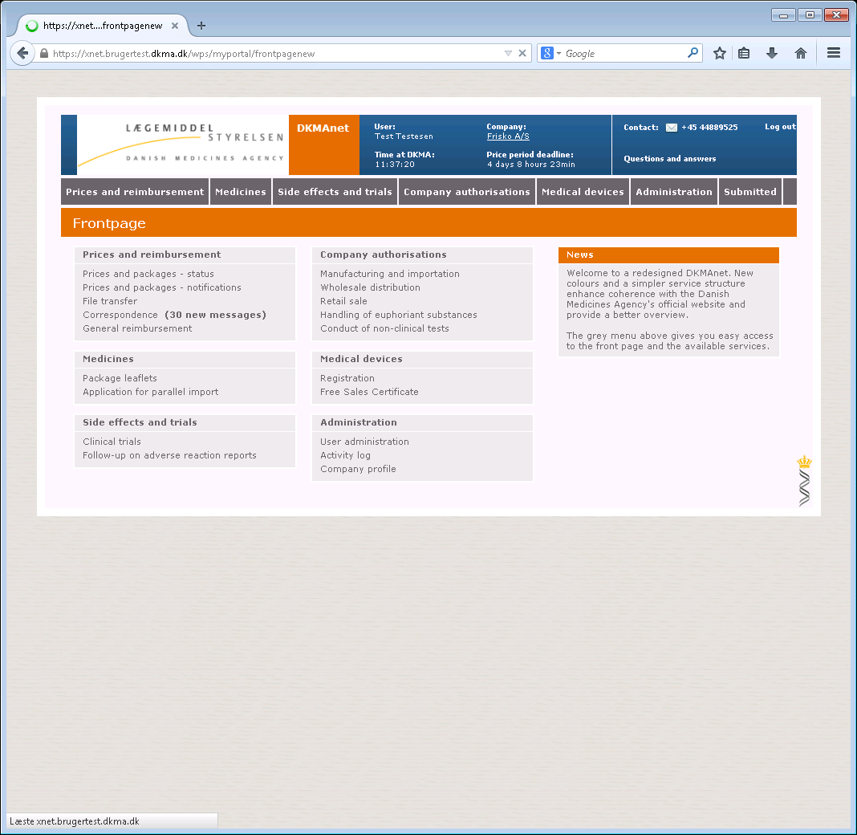

# Configuration of DKMAnet

The pages in DKMAnet are divided into fields of which some are shown on all pages, while others change depending on the function selected. Functions and tabs will vary depending on whether you have logged on as a security administrator, company administrator or a user. This will be explained further in the following chapters.

On the screenshot below, the fields are marked by a number. The contents of the fields are explained on the next page. The functions on the pages are described in detail on the following pages.

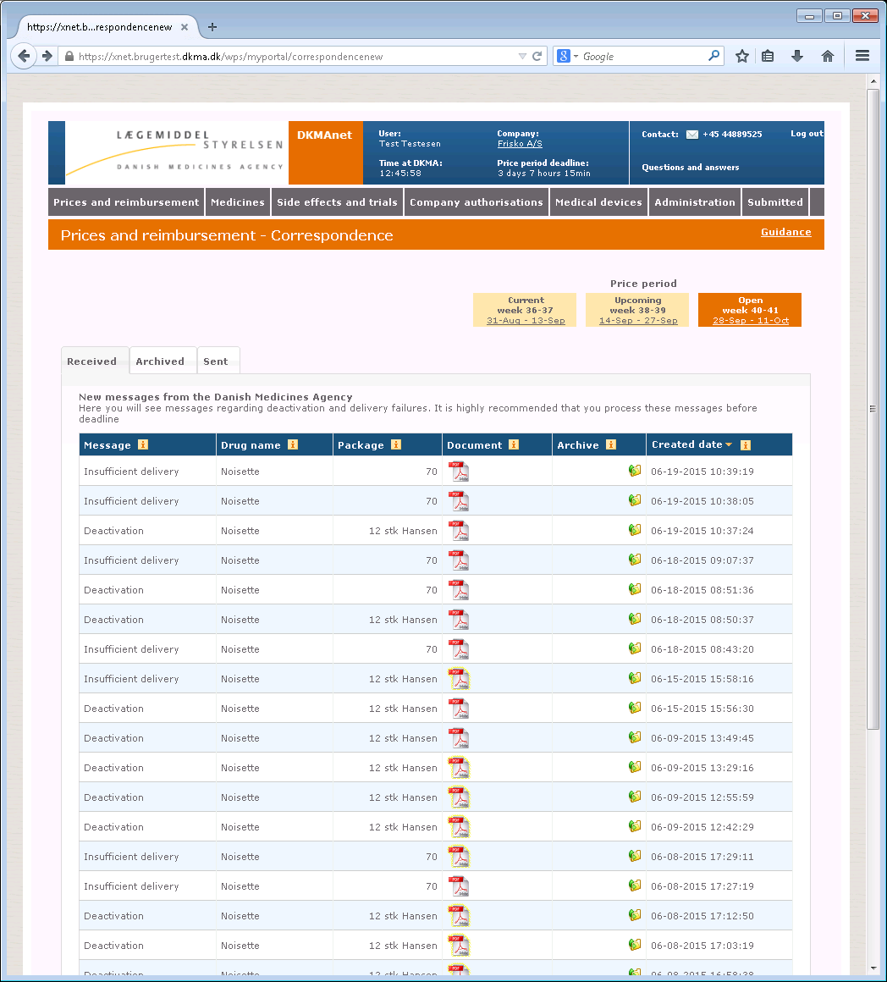

1

2

3

4

1. Contains

1. The logo of the Danish Medicines Agency
2. User and company information
3. The time on the Danish Medicines Agency's server
4. Deadline for notification
5. Contact information
6. Question and answers (link)
7. Log out of function

2. Contains a drop-down menu with access to all the functions

1. Prices & Reimbursement
2. Medicines
3. Side effects and trials
4. Company Authorisations
5. Medical Devices
6. Administration
7. Submitted

3. Contains

1. Price periods
2. A link to the guidance document

4. Contains detailed information on the selected functions

1. Link to Show as PDF
2. Info buttons in columns
3. Sorting buttons in columns

# General functions

Below are described a number of functions that appear on all pages.

## Searching

Searches are made from one field. It is possible to search by:

* Product number
* Product name
* Drug form
* MA number (MA no.)

It is also possible to search by parts of product names or drug forms, e.g. [eltro] or [ava].

You may also choose to combine your search on the basis of the above criteria with the use of comma separation, e.g. [ava, tablet]. The result of this search will be all medicinal products in tablet form containing "ava" in the product name.

The result of your search will depend on your navigation on functions and/or tabs under "Notifications" and "Status", respectively.

This means that if you e.g have searched for a product name under "Status" > "Open", the result of your search will follow if you choose the "Upcoming" price period, while it will not follow if you choose "Notifications". Similarly, your search results under "Notifications" will not follow if you proceed to the "Status" page.

If you wish to view the full assortment, you must delete the text in the search field and select "Search" or press [Enter].

If a match cannot be found in a search, the list will be empty and the numbers to the right of the search field will be 0 – 0 | 0.

*Note! Please note that if you perform a very broad search, e.g. "tablet", the search may return a considerable number of hits. For that reason, it is recommended that you limit your search by using product number or name.*

## Refresh

To refresh the page you are on, click "Search" with an empty search field.

## Guideline

Each page contains a guideline. For example, if you go to "Notifications" > "Prises and assortment" and click the link "Guideline", you will receive instructions about the functions on that page. When clicking "Back", you will return to the page you came from before you clicked "Guideline".

## Show as PDF – printouts and receipts

On the primary screens, it is possible to view printouts and receipts as PDF files. This function requires that popups are enabled (check for toolbars from Google, Yahoo, MSN etc. and if any virus program is set up to block popups). The PDF view shows the date, time, user ID and page number. The PDF file will list the contents of the page you are on when clicking the link. Consequently, the file is generated from, for example, a search result of specific medicinal products sorted as shown on the page.

## Print/Save function

You can print, among other things, your assortment or notifications by means of "Show as PDF". When the PDF file has been generated, you may choose to save the file on your PC or to print the PDF file.

## Contact

Click "Contact" to generate an email to the Danish Medicines Agency's support mailbox.

## Log out

This will ensure that you log correctly out of DKMAnet when you do not need to use the system anymore. If there are any unsent notifications, you will be prompted whether you are sure that you wish to log out.

Note! If DKMAnet is not used for more than twenty minutes, you will automatically be logged out. If there are any unsent notifications when you are automatically logged out, they will be lost.

## To company profile

Brief information about the user's company.

## Deadline for notification

This indicates the time remaining before the deadline for notification.

We recommend that you submit notifications one hour before deadline, as a minimum, if you want to be sure that you receive a validation of all price notifications and have the opportunity to make any corrections (upon receipt, new price notifications are validated every ten minutes to ensure that they respect the minimum price deviation). Please note that the deadline does not apply to the updating of package leaflets.

## The time at the Danish Medicines Agency

The time on the Danish Medicines Agency's server is the same as the official Danish time and governs the notification deadline.

## Correspondence

Under "Correspondence", you can see messages from the Danish Medicines Agency to your company (the "Received" tab). Any messages concern consultation in connection with delivery failure and deactivation.

The "Archived" tab contains the messages you (or other users from your company) have chosen to archive.

The "Sent" tab shows the status of the notifications your company has submitted through "Notifications" > "Other changes" (messages regarding commencement of approved variations) and packages notified as being phased out.

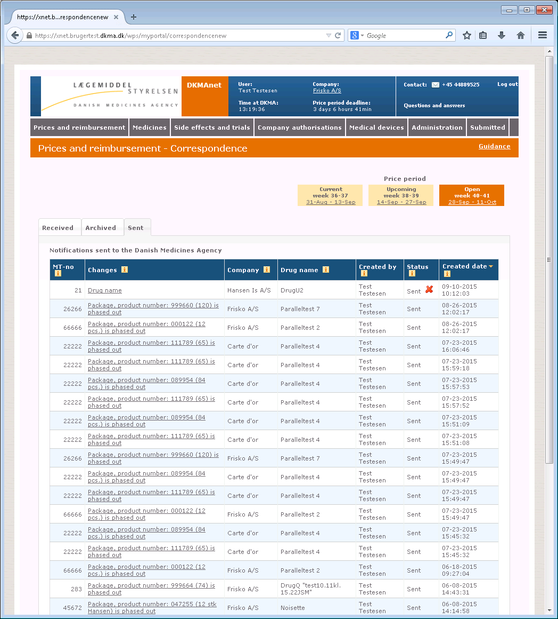

## Status

Under Status, your company's full assortment is shown as well as the status of the individual packages if notifications have been submitted (when either "Upcoming" or "Open" has been chosen under price period).

The overview shows 25 packages at a time. Use the arrows to view the next or previous 25 packages. If you wish to view all packages, click "View all".

You can use the search field to find a specific package within the selected price period.

*Note! Please note that the assortment may vary depending on the selected price period.*

### Price period: Current

In the "Current" price period, you can see your company's assortment in the pharmacies in the current price period.

The period is locked and cannot be edited. If the medicinal product is substitutable, the "PPP" column will show which substitution code your package has been allocated in this period.

### Price period: Upcoming

In the "Upcoming" price period, you can see the assortment in the coming price period. The period is locked and cannot be edited. In this price period, you can see:

1. For which packages your company has made notifications
2. Which changes have been notified
3. When the notifications were made
4. Status of the individual notifications (accepted (A), not accepted (N))

### Price period: Open

In the "Open" price period, you can see your company's assortment in the period which is still open for notifications. In this price period, you can see:

1. For which packages your company has made notifications
2. Which changes have been notified
3. When the notifications were made
4. Status of the individual notifications (Submitted, Received, Not accepted)

## Administration

Under "Administration", the security administrator can create and manage the company's company administrators and users. This function is not shown if you are logged on as a normal company user. Please refer to Chapter 6 for details about the use of "Administration".

## Company profile

Company profile shows the master data for the company/companies to which the current user has access. It also features an overview of the other company users associated with the company as well as a link to administration of these users (only available to security administrators).

# Notifications

"Prices and reimbursement” comprises the sub-functions "Prices and packages – notification” and "File transfer". "Prices and packages" is used for manual entry of notifications, and "File transfer" is used for transfer of XML files.

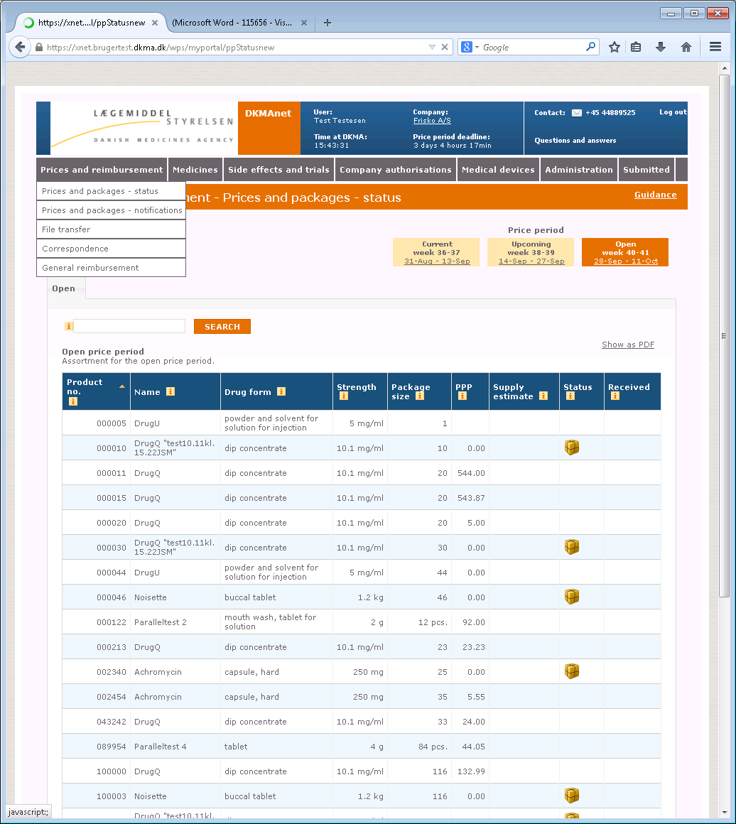

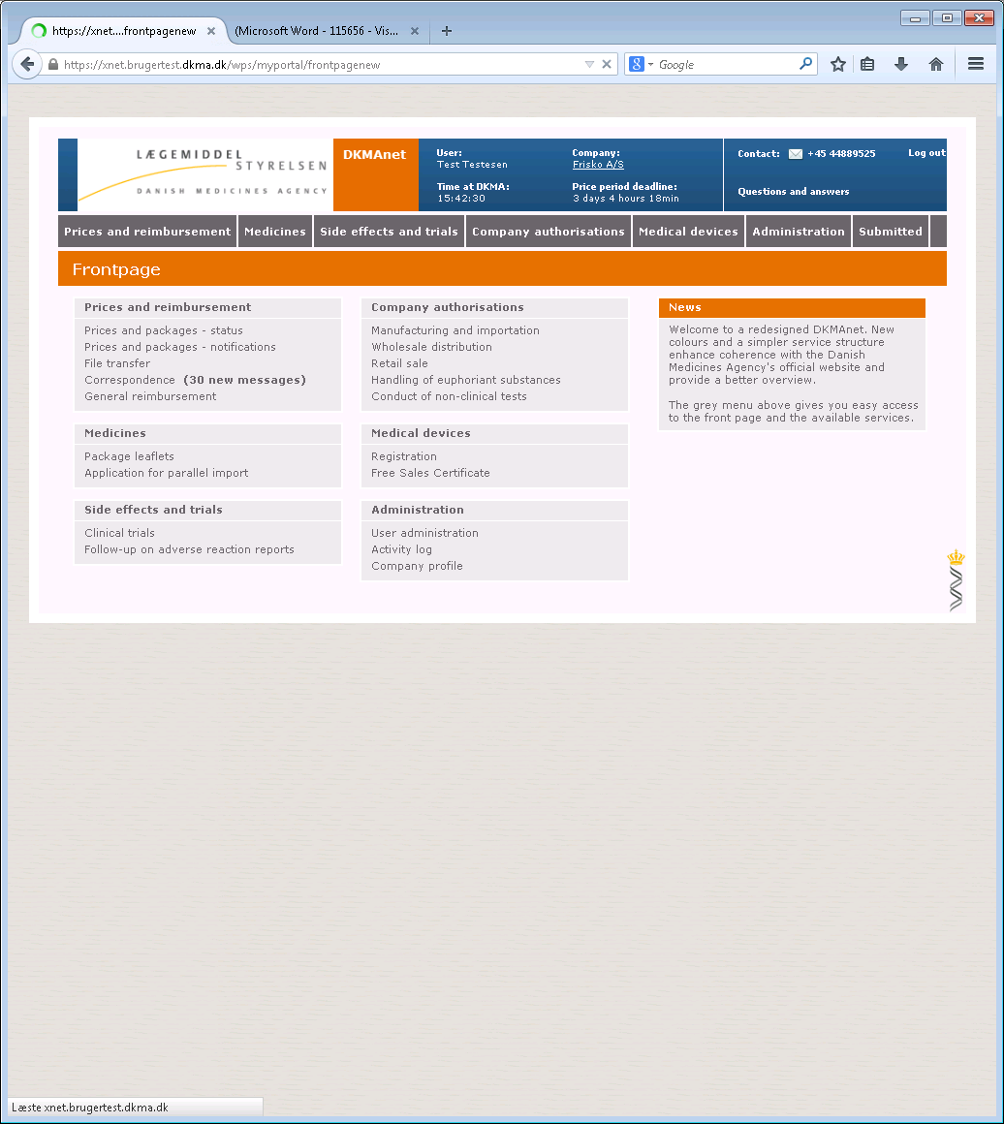

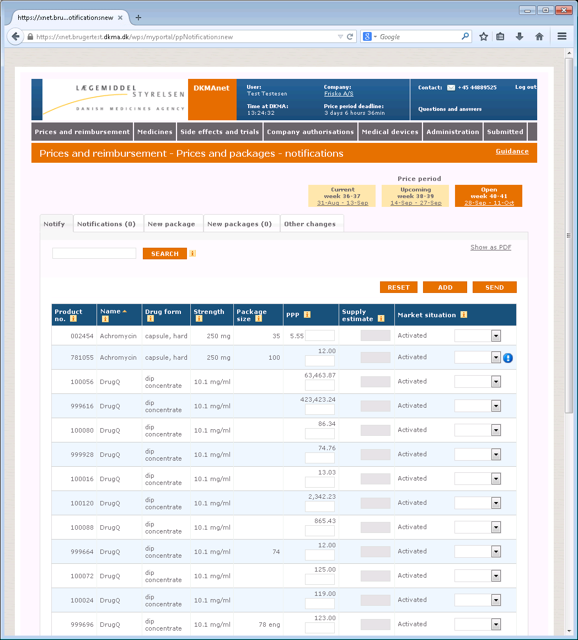

"Reset" cancels all entries made under the "Notify" and "New package" tabs. If you select this function, you will be prompted to confirm that you wish to reset.

Please note that you will only cancel notifications that have not been submitted.

"Add" is a temporary save function where you can collect all notifications before they are submitted to the Danish Medicines Agency. Changes made on the "Notify" tab are collected on the "Notifications" tab, while changes made on the "New package" tab are collected on the "New packages" tab.

"Send" will submit all changes to the Danish Medicines Agency immediately.

You will only pay for one notification per package per price period. Notifications may be overwritten up to the deadline. This means that only the last notification is valid.

*Note! If you wish to have time to discover and correct any errors in your notifications after the Danish Medicines Agency's validation, it is recommended that you submit all notifications by 7:00 pm on the day of the deadline.*

*Note! Please note that notifications not submitted to the Danish Medicines Agency will be lost if you close your browser window without submitting them.*

## Prices and assortment

When notifications have been made for a medicinal product, the  icon will appear to the right of the line containing the product. By hovering the mouse over the icon, you will see which notification you have made. If you wish to withdraw a notification, you must hover the mouse over the icon and right-click. Then, you will be prompted to confirm or cancel the withdrawal.

To view all changes submitted to the Danish Medicines Agency in the "Open" price period, you must select "Overview" > "Status" and ensure that "Open" is the active price period.

### Notify

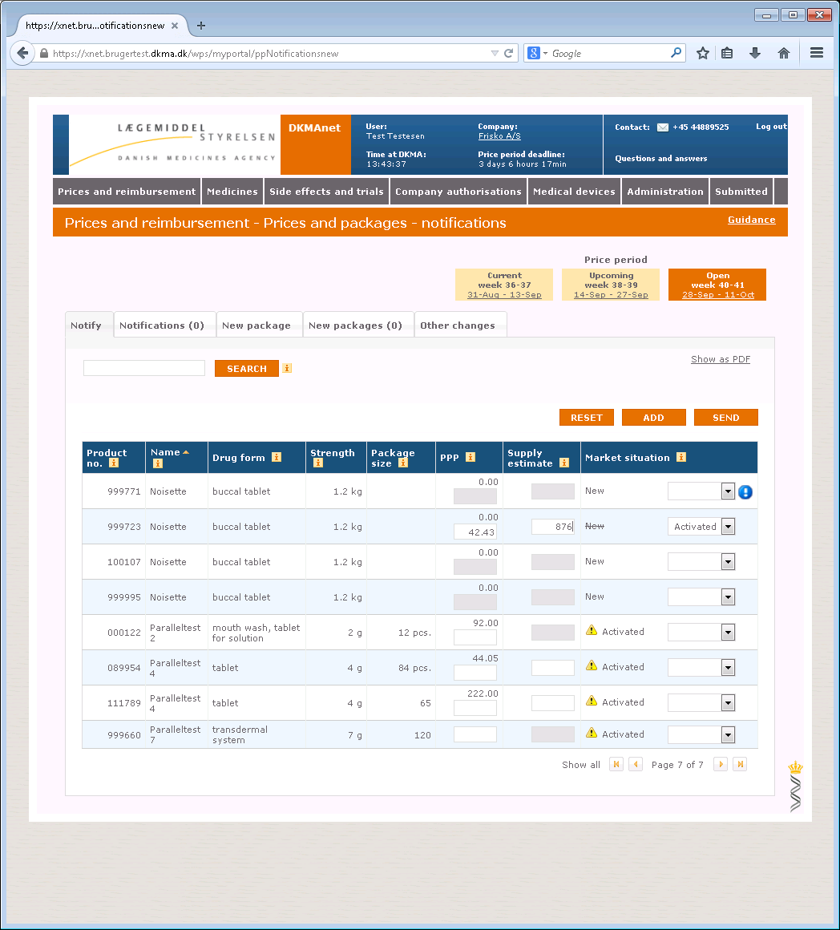

To notify the Danish Medicines Agency of a new price, market situation and/or supply estimate, if any, go to "Notifications" > "Prices and assortment" and click "Notify".

Find the package to be changed, either by scrolling down the list or by searching for the package(s).

If a notification has already been made for a package, a blue icon – an exclamation mark – will appear to the right of the package. By hovering the mouse over the icon, you will be shown a box containing information on the notification.

Please note that the supply estimate field is only active for the packages where notification of the supply estimate is mandatory. If the field is not active, it is not possible to enter a supply estimate.

Make the required notification and click "Add" or "Send".

**Phasing out of packages:**

Select "Being phased out" to phase out a package. When such message is sent, the package will automatically be phased out over three price periods. The message can be seen under "Status" > "Correspondence" > "Sent".

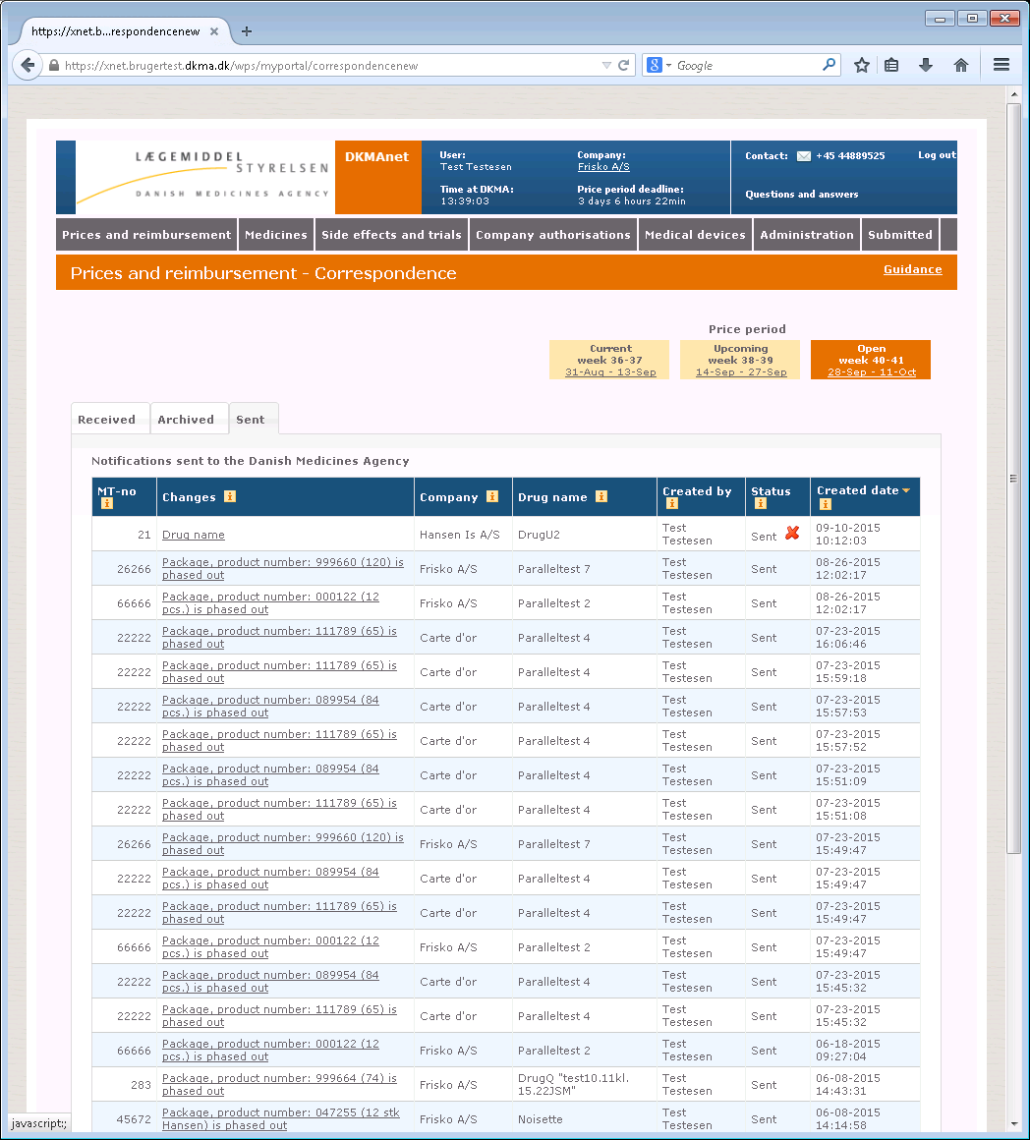

Phasing out does not mean that it is not possible to notify the Agency of prices and market situation regarding the package.

If you have chosen to use "Add", the "Send" button will disappear and you will then have to enter "Notifications" to send the entire package of changes.

*Note! Please note that price changes must be +/- 1 Danish krone. The notifications submitted are automatically validated every ten minutes. If the price is changed by less than 1 krone, the status of the notification will change to "N" – Not accepted.*

*Note! If a supply estimate is required, but not entered, you will see an error message if you attempt to send the notification to the Danish Medicines Agency or add it to "Notifications".*

### Notifications

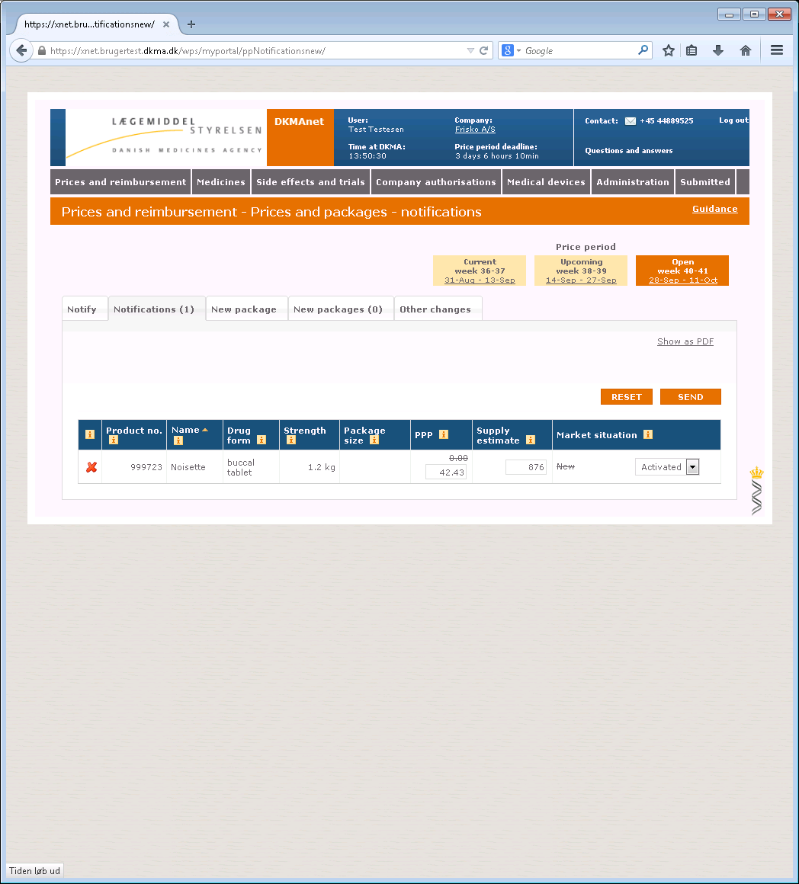

When you are ready to send your notifications to the Danish Medicines Agency, select the "Notifications" tab. In the parenthesis on the tab, you can see how many changes are pending.  
Before you click "Send", you have the opportunity to verify the notifications and correct them if you have made incorrect entries. You can also use the red cross in the left part of the overview to delete one notification from the list.

Click "Send" when all notifications are correct. When all notifications and any new packages have been sent to the Danish Medicines Agency, the status page will automatically be shown. Here, you can see your notifications in the assortment overview.

### New package

In order to use DKMAnet, you must have applied for and received a product number from Danish Medicinal Product Information (DLI). Then, you can start using DKMAnet to create and market the package.

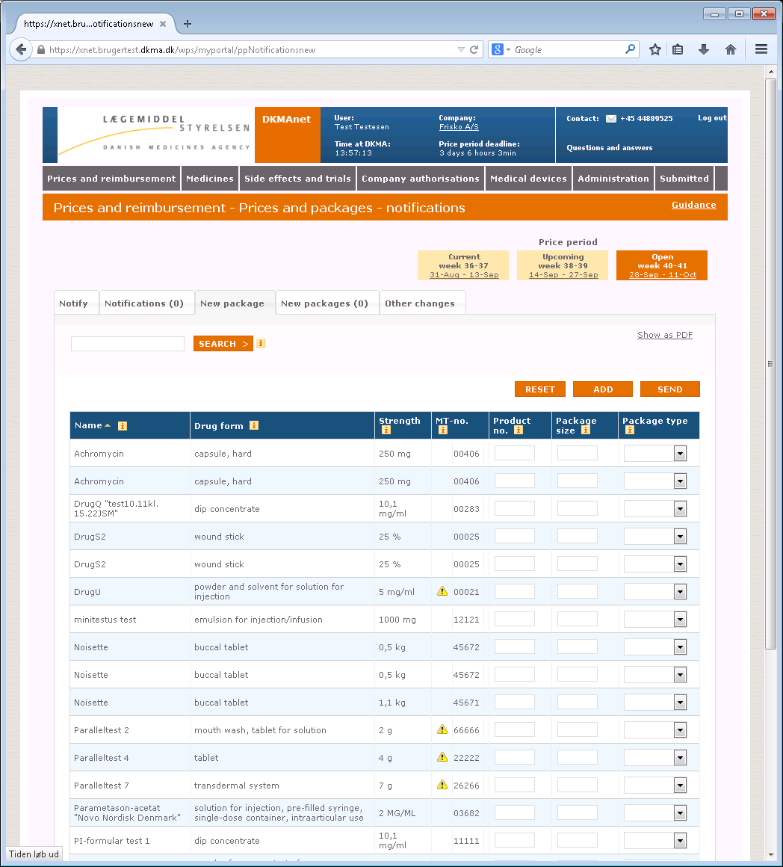

1. Find the package to be created in the list, either by scrolling down the list or by means of the search function. Please note that tab "New package" may be used to search for a package using the relevant name, drug ID or drug form. To search for a package using the MA no., the tab “show all” should be clicked before you use the browser’s search function.
2. Enter the product number received from DLI as well as the package size and type.
3. Click "Add" or "Send".
4. If you click "Send", the newly created package will be shown on the "Notify" tab, and you can now activate the package (in the "Market situation" column in section 5.1.2) and then enter price and supply estimate. Please note that you must always enter a supply estimate when activating new packages. Finally, click "Send" on the "Notify" tab.

When you have created and activated (marketed) a new package, it will immediately appear as "created" in your assortment. By hovering the mouse over the blue exclamation mark to the right of the overview on the "Notifications" tab, you will see that in addition to being created, the price of the package has also been notified to the next open price period.

### New packages

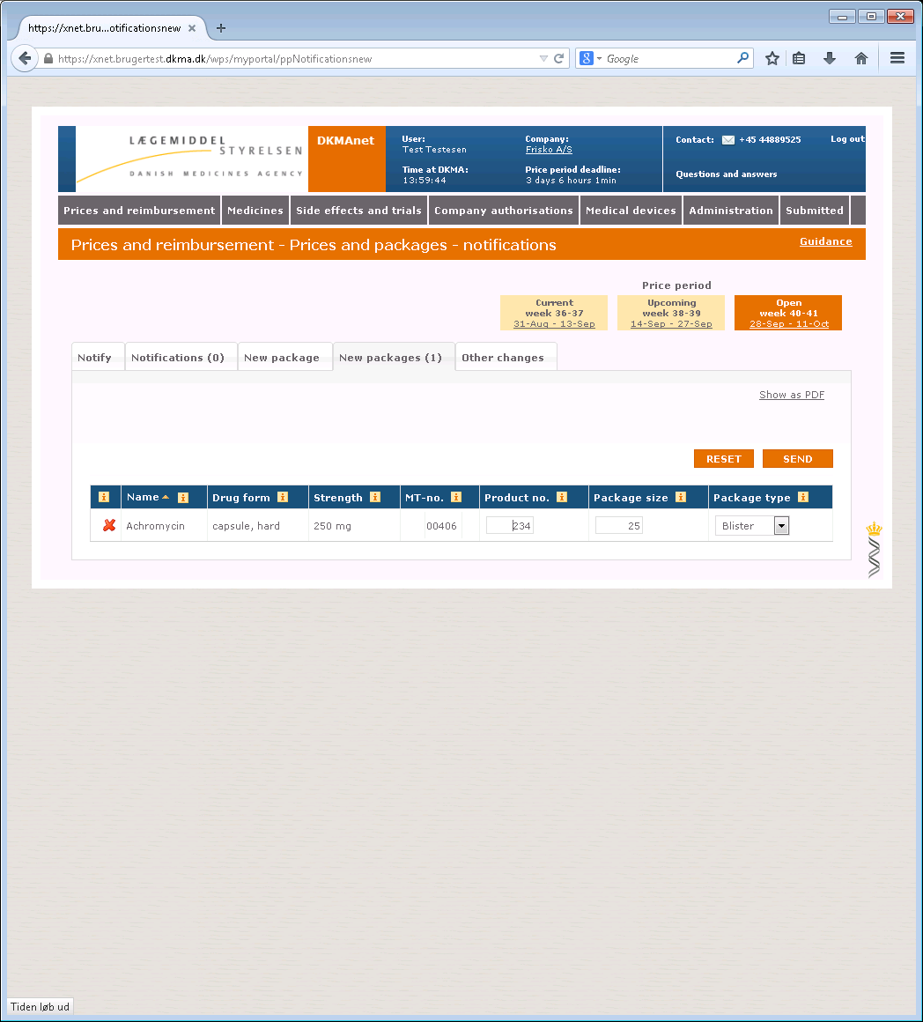

When you are ready to send the packages created to the Danish Medicines Agency, select the "New packages" tab. In the parenthesis on the tab, you can see how many packages are pending.

Before you click "Send", you have the option of verifying the changes and correct them if you have made incorrect entries. You can also use the red cross on the left to delete one package from the list.

Click "Send" when all changes are correct.

If you click "Send", the newly created package will be shown on the "Notify" tab, and you can now activate the package (in the "Market situation" column) and then enter price and supply estimate. Please note that you must always enter a supply estimate when activating new packages. Finally, click "Send" on the "Notify" tab.

When you have created and activated (marketed) a new package, it will immediately appear as "created" in your assortment. By hovering the mouse over the blue exclamation mark to the right of the overview on the "Notifications" tab, you will see that in addition to being created, the price of the package has also been notified to the next open price period.

### Other changes

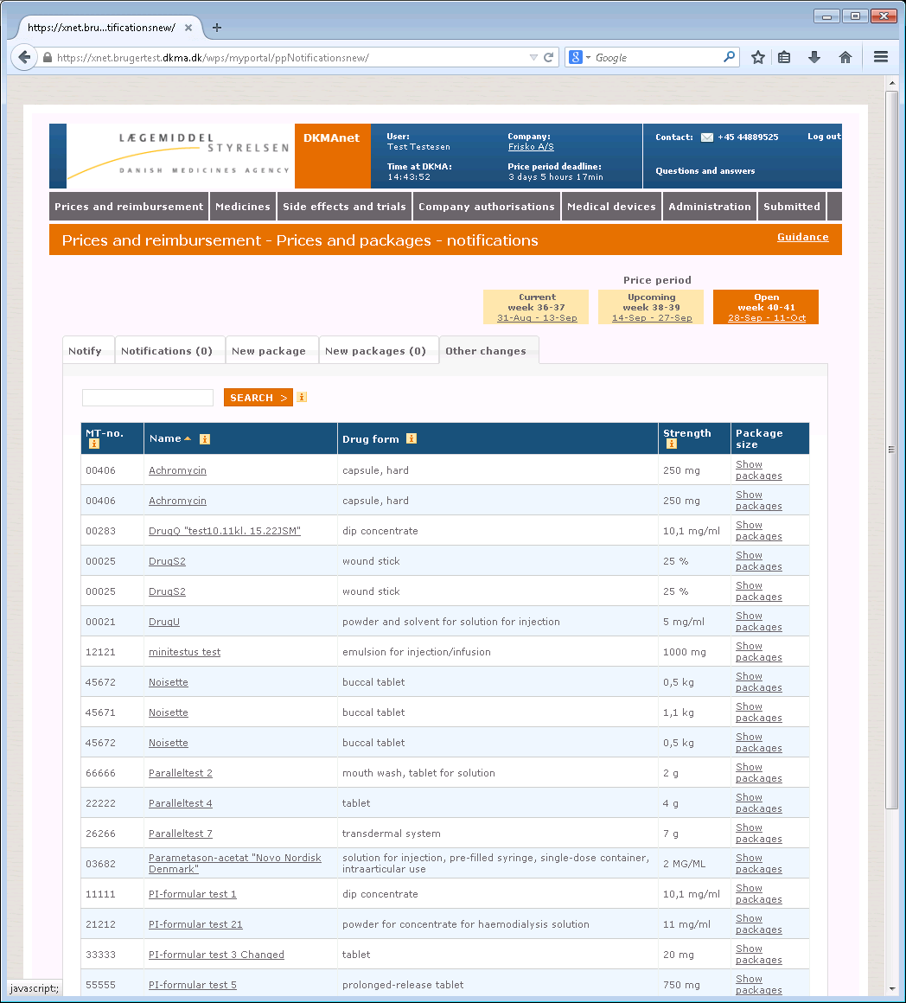

For medicinal products for which the company wishes to let an approved variation application enter into force from the "Open" period, the relevant product must be selected by the underlined link containing the name of the product. Then, the following page will be shown:

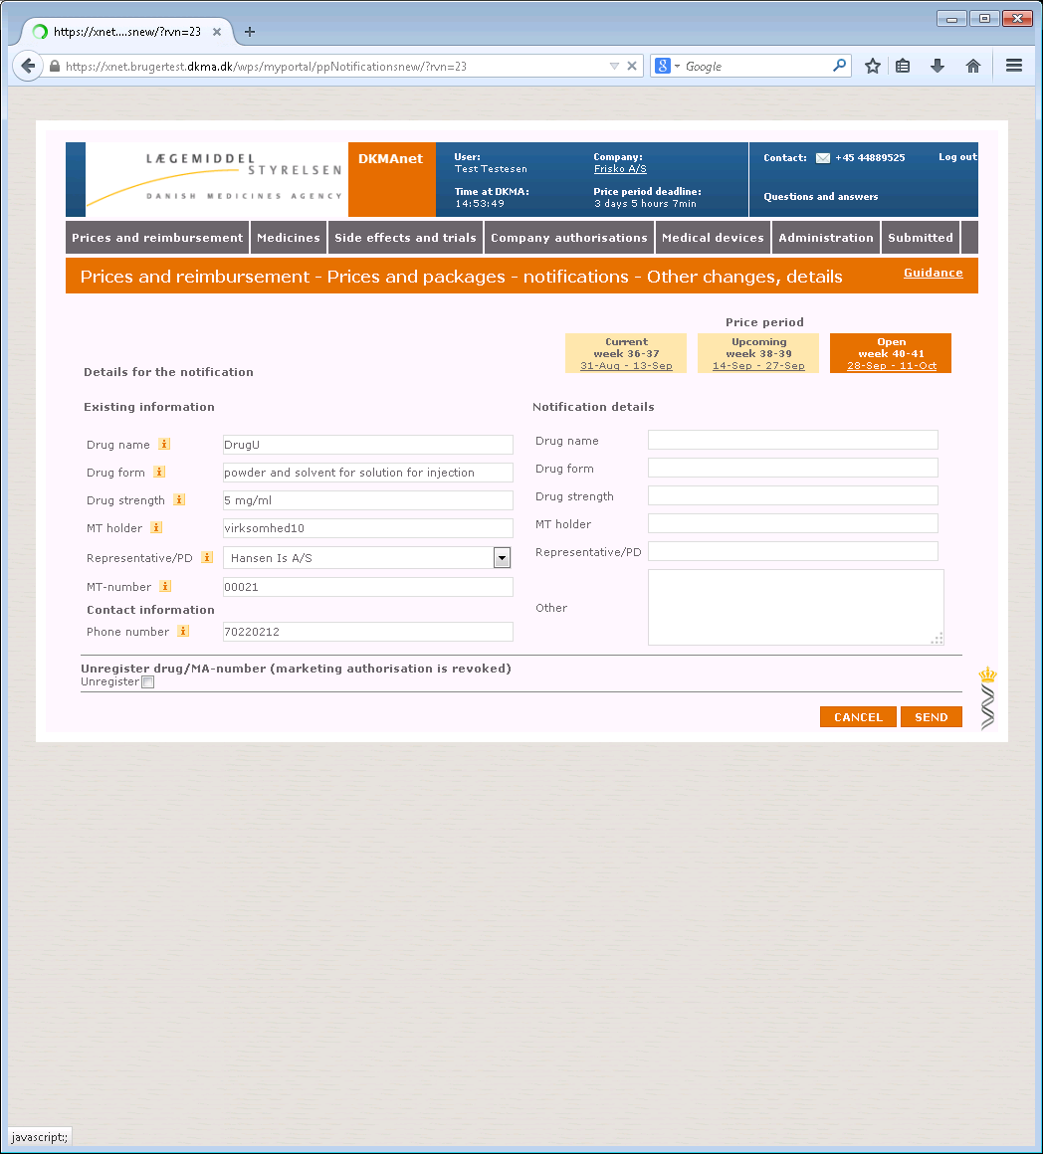

**3**

**2**

**1**

1. Enter the relevant text from the approval letter on the right side of the formula.
   1. The name, form and strength of the medicinal product must be written exactly as indicated in the approval letter.
   2. For changes regarding the MA-holder and Representative, the company number should be written in the “other” section of the formula.
   3. Remember to add the case number found in the approval letter to the “other” section of the formula.

*Note! It is only the company transferring a medicinal product to a new company that is responsible for notification. For this reason, the acquiring company cannot see the medicinal product in DKMAnet before a notification has been submitted.*

1. Please enter a telephone number where the Danish Medicines Agency may reach you (or a colleague in case of sickness or holidays)
2. If you select "Deregister medicinal product", you must enter a reason code for the deregistration. This will prompt a warning to ensure that you do not inadvertently deregister a product.

*Note! If your notification concerns a change of names (or the like), you will be able to create new packages. You should, however, note that the name of the product will only be changed after the change of periods. In connection with changes of names, you must look for* https://xnet-test.dkma.dk/wps/PA_1_0_2B1/theme/warning.png (outstanding notification) *in front of the MA no. on "Notifications” > ”Prices and assortment” > ”New package”*

The current name will be displayed here, until the name change is valid.

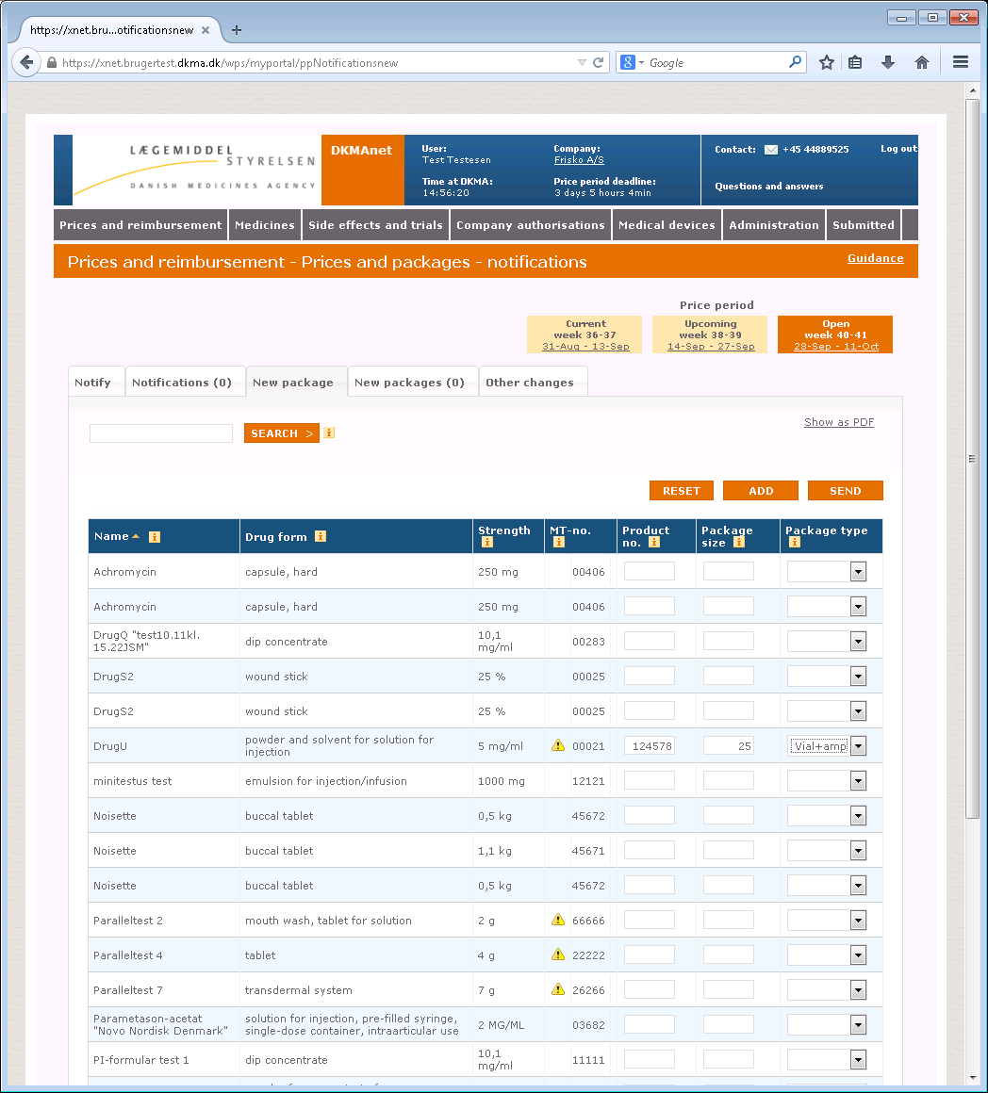

The current name will be displayed here, until the name change is valid.

## File transfer

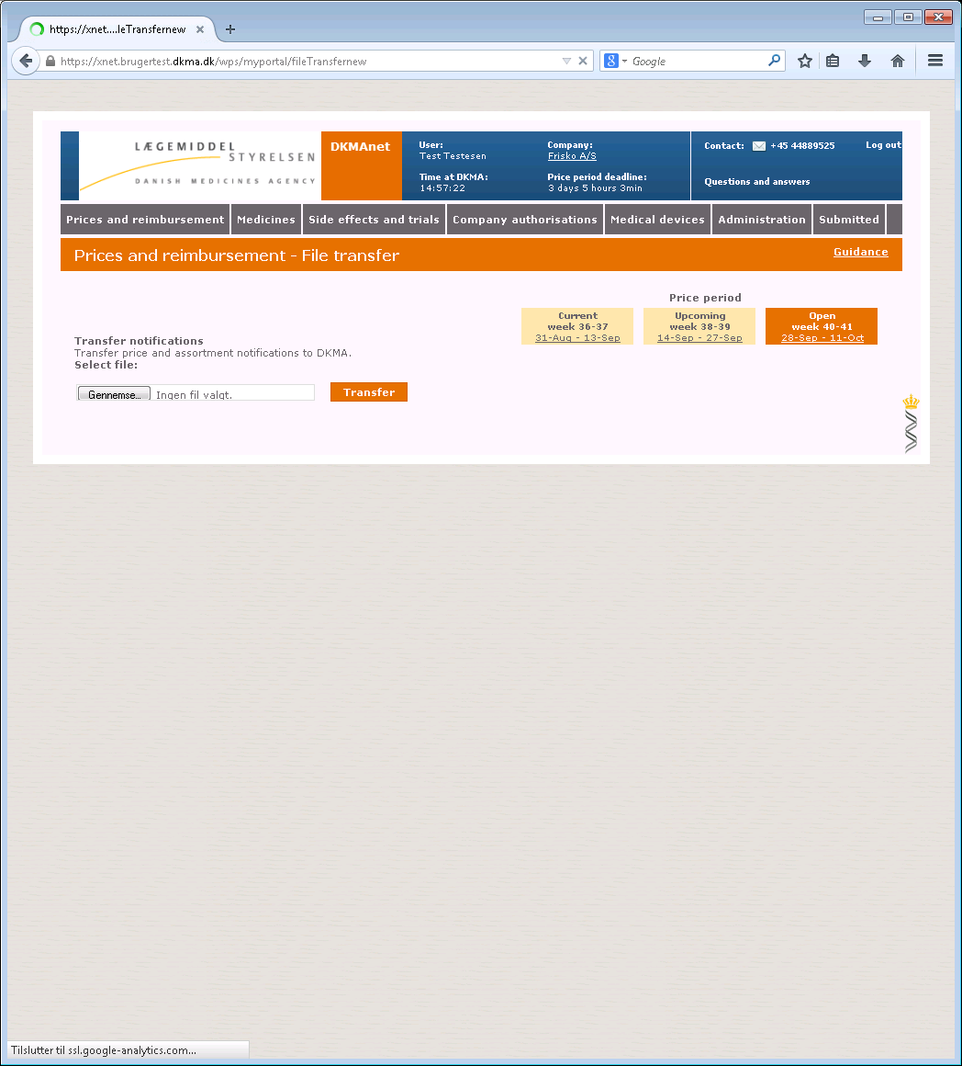

Very often, it is more practical to transfer notifications by means of a file transfer. If you have many notifications, a file transfer will be a quicker solution. Another advantage is that the risk of error is greatly reduced because you will not have to enter data manually.

Select "File transfer" under "Prices & reimbursement" and click "Browse". You will now be able to select your XML file on your PC or network.

Click "Transfer" when the file has been selected. If the notification data in the file are correct, they will be uploaded to the system and automatically shown on the "Status" page.

If you have any changes to one or more of the notifications from the transferred file, you may either transfer a new file with corrections or correct them manually on the "Notify" page (see the description of "Notify").

## Package leaflets

On [www.indlaegsseddel.dk](http://www.indlaegsseddel.dk), consumers have access to package leaflets for medicinal products. These package leaflets can be maintained in the "Package leaflets" function:

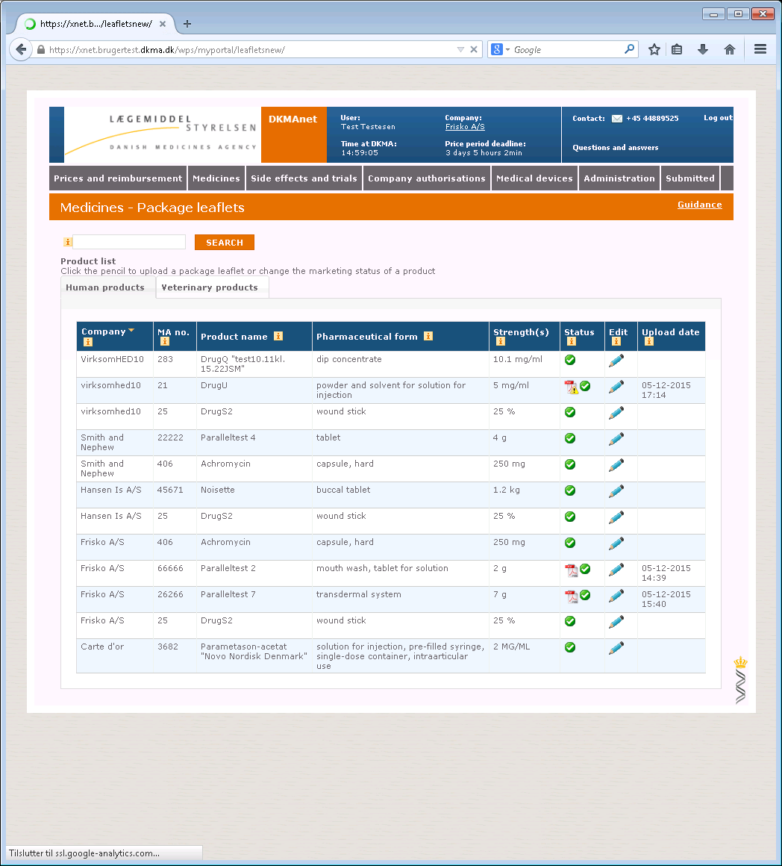

Package leaflets are attached to medicinal products with the same form with the possibility of attaching one or more package leaflets to the individual strengths within the same name and form.

Click [https://xnet-test.dkma.dk/wps/PA_1_0_2B1/theme/pencil.gif](https://xnet-test.dkma.dk/wps/myportal/!ut/p/kcxml/04_Sj9SPykssy0xPLMnMz0vM0Y_QjzKLN4gPcALJgFjGpvqRINrEBSbiCBFAKAkwgYiEWcJFjDDUGGKImMJFfD3yc1OB4pHmQL6Rq6V-iH6kE5zv7Qbiu-h76wfoF-SGgkBEuaGFoYWjoiIAIxPRig!!/delta/base64xml/L3dJdyEvd0ZNQUFzQUsvNElVRS82XzBfUzY!##) to attach a package leaflet. Then, the following page will be shown:

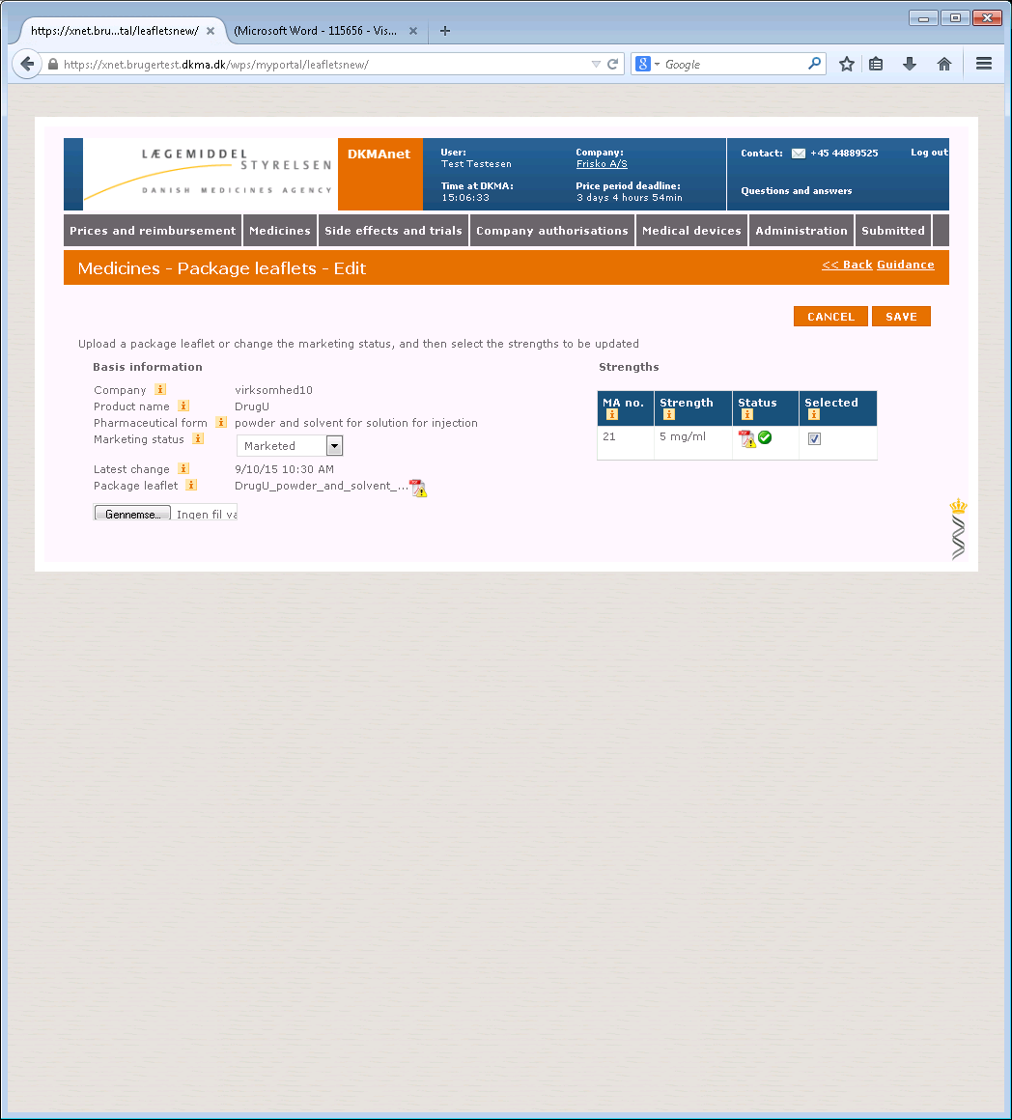

3

1

2

1. "Marketed"/"Not marketed". Here, you can indicate the market situation of medicinal products not included in Price List (e.g. herbal medicinal products).

*Note! The function only serves an informative purpose for the consumers and does not concern the product's approval status.*

2. View the existing package leaflet or upload a new one by clicking "Browse".

*Note! Package leaflets must be in Danish and in PDF format. The layout and content is the exclusive responsibility of the company.*

3. If there are more strengths for the product name and form in question, you can check "Selected" to indicate whether the package leaflet applies to one or more strengths.

Press “save” if the package leaflet should be available on [www.indlaegsseddel.dk](http://www.indlaegsseddel.dk) or click “cancel” to undo the action.

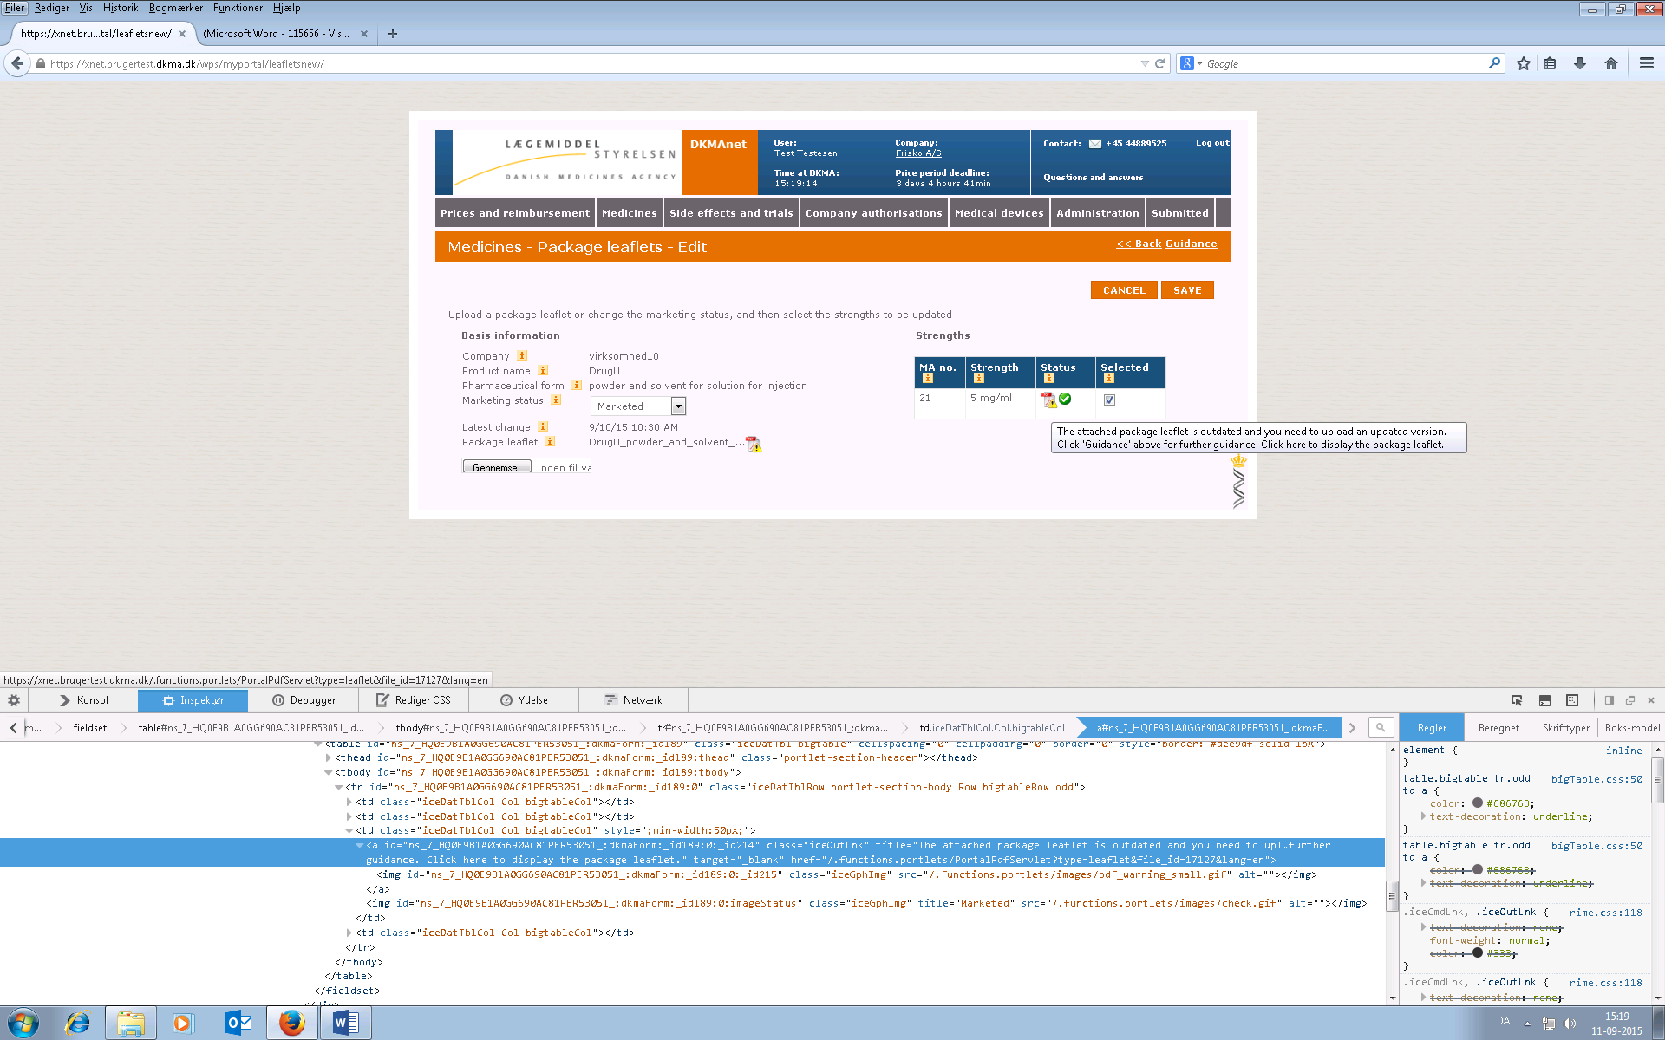

*Note! A yellow warning triangle on the package leaflet means that you have changed the attachment between strengths and package leaflets. For example, you may have chosen to upload a package leaflet for one strength without uploading a new one for another strength.*

*Note! Once a medicinal product has a package leaflet attached, you will not be able to remove it. You will only be able to upload a new and better version.*

# Administration

This chapter is only directed at security and company administrators. Other company users do not have access to the Administration function.

Administration comprises the following functions

* Create CA (company administrators)
* Create CU (other company users)

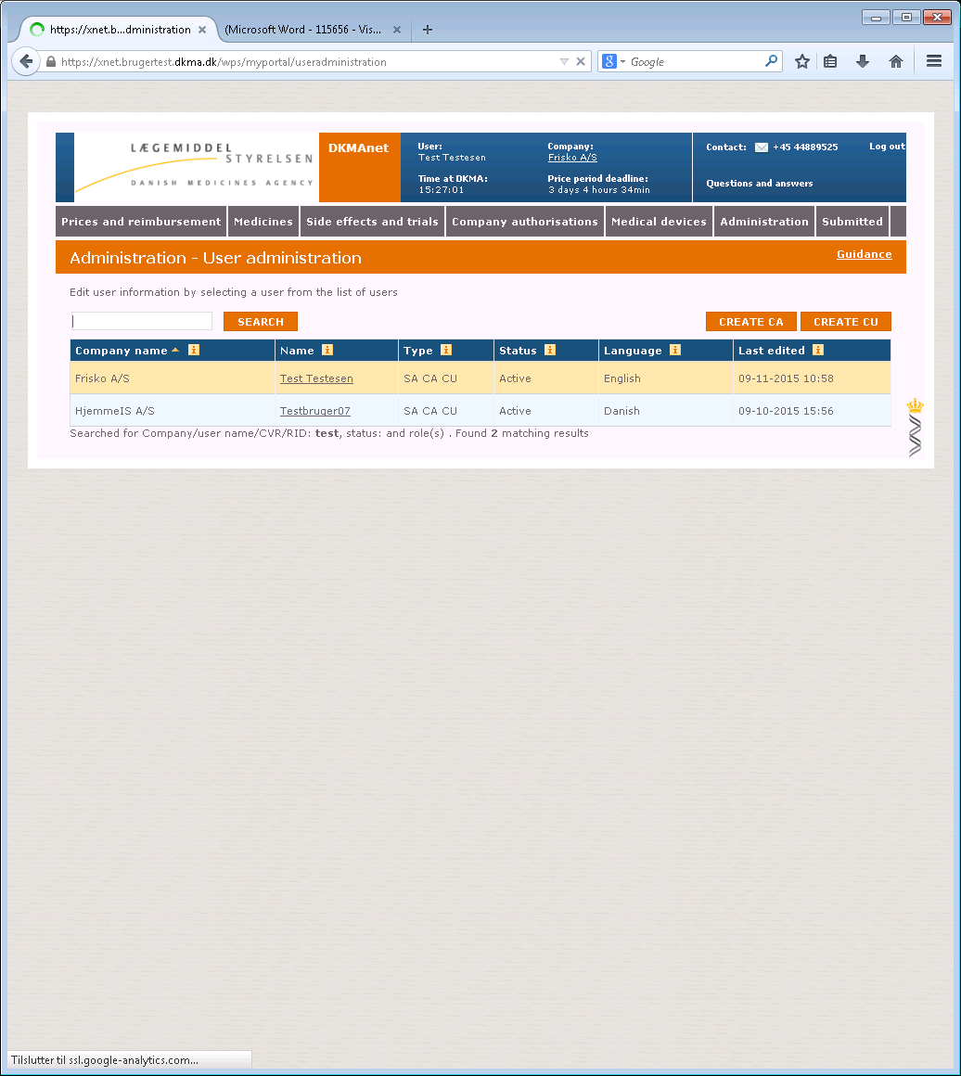

## Create company administrators and other users

After clicking on the tab ”create CA” or ”create CU” the following page will be shown:

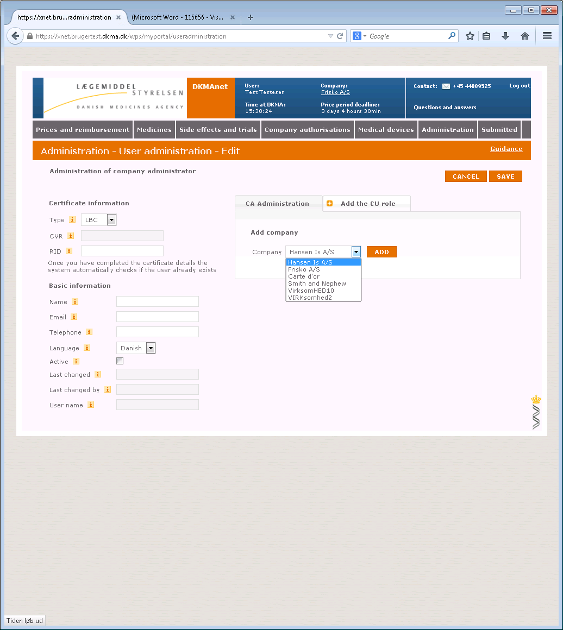

When creating new users in your company, you must fill in the following fields. This is applicable for both the CA’s and the CU’s:

**Basic information**

|  |  |
| --- | --- |
| **Field name** | **Information** |
| Name | The user's name |
| Email | The user's email address |
| Phone | The user's phone number |
| Language | Select Danish or English in the drop-down box.  *Please note that the selection of language also controls whether DKMAnet is shown in Danish or English* |
| Rights | Select whether the user should have read-only or writing rights. |
| Active | Indicate whether the user is to be activated immediately. |
| Last edited | Automatically completed by DKMAnet. |
| Last edited by | Automatically completed by DKMAnet. |

**Certificate information**

|  |  |
| --- | --- |
| **Field name** | **Information** |
| Type | Select the certificate type for the company.  OCES = digital signature for Danish companies and individuals  LBC = Closed user group certificate. To be created as agreed with the Danish Medicines Agency. |
| CVR no. | Your company's registration number which is shown on the company's certificate and to which the certificate is attached. The CVR number contains eight digits. |
| RID | The RID number is shown on the employee certificate with the CVR number. The RID number contains thirteen digits. |

**Associated companies**

If you have access to more company numbers, you can choose to which company or companies the user will have access. If different addresses or companies exist, you must choose which main company the user will be associated with.

Click "Apply" when all fields have been filled in. The user has then been created and will be shown on the user list on the "Users" tab.

Once the user has been created and attached to a number of companies a range of functionalities will appear. Assigning a specific functionality to a CA means that, the CA can designate the same functionality to other CU’s (and their own account).

**Functionality areas**

Choose which rights the user in question should have. A user with read-only access to Prices and Packages (P and p) is not permitted to make notifications. A user with writing access to P and p is permitted to make all types of notifications regarding prices and assortment.

Access to package leaflets may be divided between human and veterinary products.

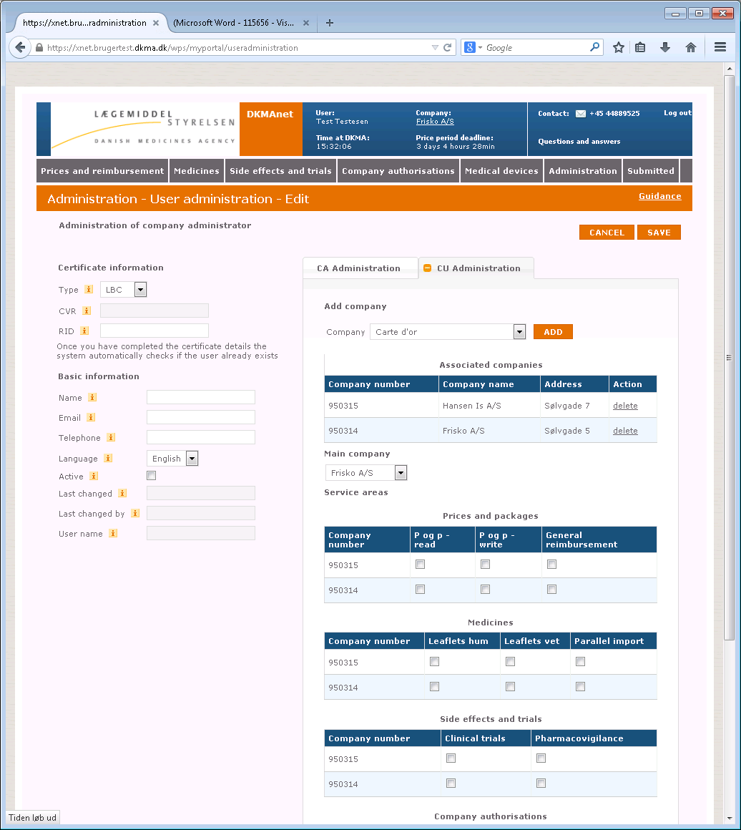

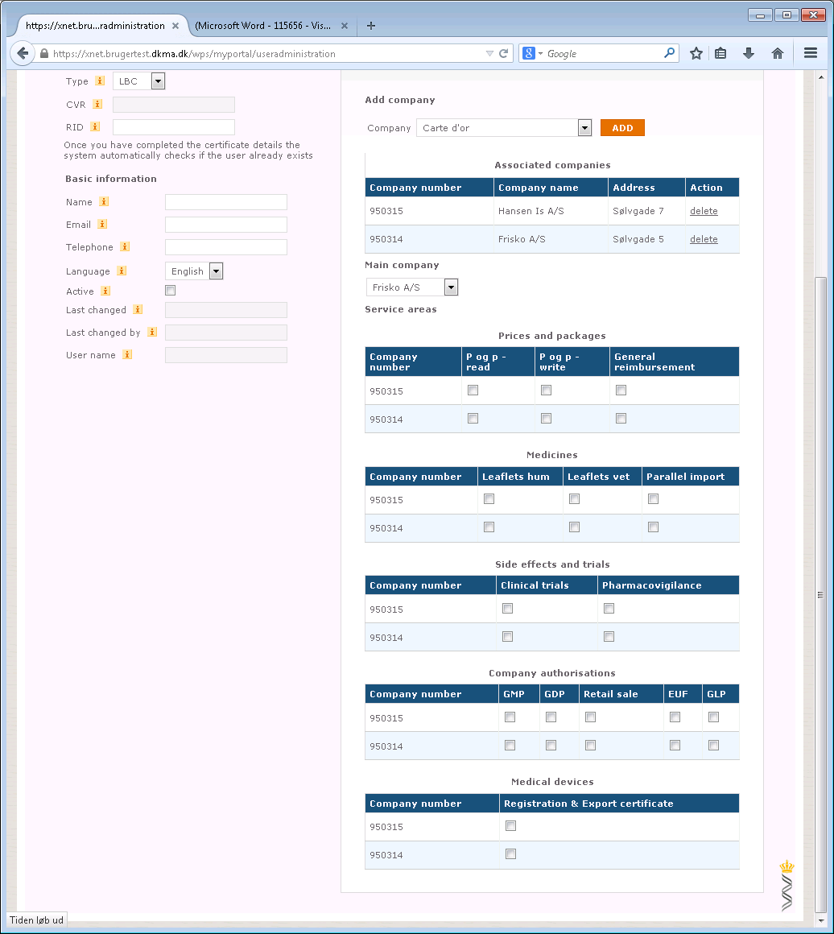

## Administration of users



The "Users" tab shows a list of the company's users. Please note that your account is displayed first on the list and the line is marked with yellow. The list contains both active and inactive users, as all user information must be saved in accordance with the Danish Act on Processing of Personal data and for the purposes of data security.

When new users are created, the system will automatically generate a user ID based on the users name. The user ID makes is possible to create more than one user with the same name, and the system is still able to differentiate between these, thanks to the user ID. Thus, it is possible for users with similar names to make notifications, because they will be distinguished by the user ID.

Changes to the users name later on, will not influence the user ID and it will remain unchanged.

Users may be retrieved in the "User name" column or by using the search field.

By clicking the user's name, the "Create user" page will be opened (see the next picture).

This page is the same as the page where users are created. The only difference is that all data for the user have been filled in.

You now have the option of:

1. Correcting relevant data (email, phone)
2. Changing the language in the user's interface (Danish/English)
3. Activating the user by selecting the "Active" field
4. Deactivating the user by deselecting the "Active" field
5. Remove access to companies (i.e. company numbers)
6. Add access to companies (i.e. company numbers)

Click "Apply" to save the corrections or "Cancel" to undo the action. When clicking "Apply", you will automatically be taken to the user overview.